Sapling Class – Literacy Tree Long Term Plan – Cycle A
Autumn 1 |  | Autumn 2
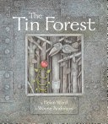  The Tin Forest  By Helen Ward (15)  Persuasive information leaflets  Persuasive posters, information leaflets, postcards, diaries, wishes, setting descriptions | 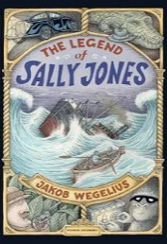  The Legend of Sally Jones  By Jakob Wegilius (16)  A further adventure in the style of the author. Birth Certificate, letter, class 'book of tricks', newspaper article, dialogue, advert, diary entry, leaflet, telegram, booklet, 'so long' note | 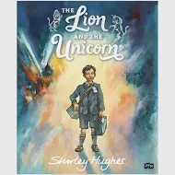  The Lion and the Unicorn  By Shirley Hughes (18)  Own historical narratives Letters, diaries, character and setting descriptions,  non-chronological reports
Spring 1 |  | Spring 2
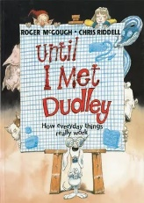  Until I met Dudley  By Roger McGough (10)  Two explanation texts - formal  and informal Letters, short explanatory paragraphs | 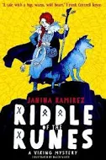  Riddle of the Runes  By Janina Ramirez (15)  Historical fiction narrative (alternative ending) Character and setting descriptions, dialogue, instructions (directions), letter | 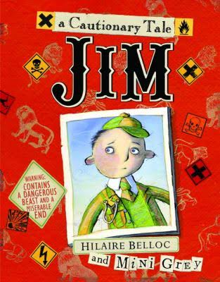  Jim, A Cautionary Tale  By Hilaire Belloc (15)  Narrative poems  Warning posters, warning announcements, alternative endings, performance poetry, letters of apology
Summer 1 |  | Summer 2
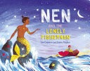  Nen and the Lonely Fisherman  By Ian Eagleton (15)  Own version narrative-Lonely hearts advert character description, thought bubbles, diary entries, message in a bottle setting description |  | 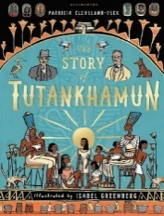  The Story of Tutankhamun  By Patricia Cleveland-Peck (15)  Tutankhamun biographies Reports, instructions, character descriptions, diaries, newspaper, posters | 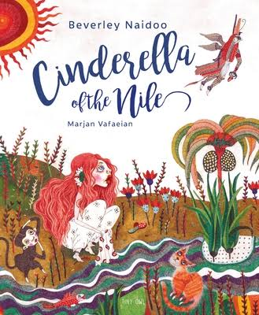  Cinderella of the Nile  By Beverley Naidoo  Own version narratives Descriptive passages, how to guides, letters, discussions, non-chronological reports

Text (Cycle A) | Narrative | Description | Diary | Poetry | Instructions | Recount | Persuasive | Letter | Leaflet | Poster | Non Chron Report
The Tin Forest |  | ✔️ | ✔️ |  |  | ✔️ | ✔️ |  | ✔️ | ✔️ | ✔️
The Legend of Sally Jones | ✔️ | ✔️ | ✔️ |  |  |  | ✔️ | ✔️ | ✔️ | ✔️ | ✔️
The Lion & the Unicorn | ✔️ | ✔️ | ✔️ |  |  | ✔️ |  | ✔️ |  |  | ✔️
Until I Met Dudley |  |  |  |  | ✔️ |  |  | ✔️ |  |  | ✔️
Riddle of the Runes | ✔️ | ✔️ |  |  | ✔️ |  |  | ✔️
Jim: A Cautionary Tale | ✔️ |  |  | ✔️ |  |  | ✔️ | ✔️ |  | ✔️
Nen & the Lonely Fisherman | ✔️ | ✔️ | ✔️ |  |  | ✔️
The Story of Tutankhamun | – | ✔️ | ✔️ |  | ✔️ | ✔️ |  | ✔️ |  | ✔️ | ✔️
Cinderella of the Nile | ✔️ | ✔️ |  |  | ✔️ |  | ✔️ | ✔️ |  |  | ✔️

Sapling Class – Literacy Tree Long Term Plan – Cycle B
Autumn 1 |  | Autumn 2
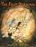 The First Drawing  by Mordicai Gerstein  Own historical narratives  Character descriptions, diaries, recounts | 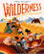  The Wilderness  by Steve McCarthy  A guide to enjoying the wilderness -Character introductions, letter of advice, descriptive poem, SOS message, identification label | 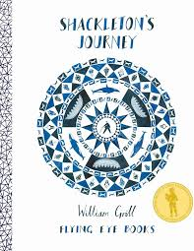  Shackleton’s Journey  By William Grill  Newspaper reports  Packing lists (justifications),  letters (formal and informal),  interviews, diaries | 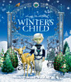  Winter’s Child  By Angela McAllister  Fantasy story sequels  Descriptive poems, postcards, dialogue, setting descriptions as letters, retellings
Spring 1 |  | Spring 2
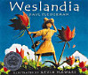  Weslandia  By Paul Fleischman  Non-chronological reports  Retellings, character  descriptions, book reviews | 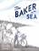  The Baker by the Sea  By Paula White  Tourist brochures Job applications,  advertisements, setting descriptions, letter in role | 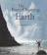  The Ever Changing Earth  by Grahame Baker - Smith  Narrative sequels  Informal letters, explanatory  leaflets, list poems, dictionary of terms | 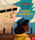  Granny Came Here on the Empire Windrush  By Patrice Lawrence  Factual report on the Windrush Generation Informal letters, factual statements, future aspirations, postcard, diary entry, a speech, quotations
Summer 1 |  | Summer 2
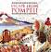  Escape from Pompeii  by Christina Balit  Newspaper reports  Setting descriptions, diaries,  letters, thought bubbles |  | 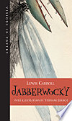  Jaberwocky  By Lewis Carroll  Nonsense poems  Performance poetry, explanatory descriptions | 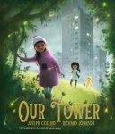  Our Tower  By Joseph Coelho  Extended fantasy narratives  Poems, setting descriptions, diary entries, dialogue, letters of thanks

Text (Cycle B) | Narrative | Description | Diary | Poetry | Instructions | Recount | Persuasive | Letter | Leaflet | Non Chron Report
The First Drawing | ✔️ | ✔️ | ✔️ |  |  | ✔️
The Wilderness |  | ✔️ |  | ✔️ |  |  | ✔️ | ✔️
Shackleton’s Journey |  |  | ✔️ |  |  | ✔️ |  | ✔️ |  | ✔️
Winter’s Child | ✔️ | ✔️ |  | ✔️ |  | ✔️ |  | ✔️
Weslandia | ✔️ | ✔️ |  |  |  |  |  |  |  | ✔️
The Baker by the Sea |  | ✔️ |  |  | ✔️ |  | ✔️ | ✔️ | ✔️
The Ever-Changing Earth | ✔️ |  |  | ✔️ | ✔️ |  |  | ✔️ | ✔️ | ✔️
Granny Came Here on the Empire Windrush |  | ✔️ | ✔️ |  |  | ✔️ | ✔️ | ✔️ |  | ✔️
Escape from Pompeii |  | ✔️ | ✔️ |  | ✔️ | ✔️ |  | ✔️ |  | ✔️
Jabberwocky | ✔️ | ✔️ |  | ✔️ |  |  |  |  |  | ✔️
Our Tower | ✔️ | ✔️ | ✔️ | ✔️ |  |  |  | ✔️

