Acorn – Literacy Tree Long Term Plan – Cycle A
Autumn 1 |  |  | Autumn 2
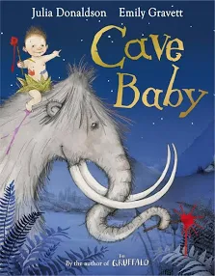 Cave Baby  Julia Donaldson and Emily  Gravett  Narrative retellings  Labels and captions, informal letters | 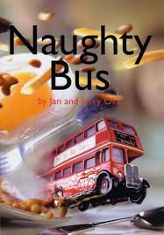  Naughty Bus  Jan Oke and Jerry Oke  Own adventure stories Letters, diaries, sequels, non-chronological reports |  | 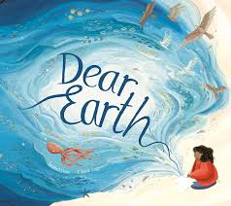  Dear Earth Isabel Otter  & Clara Anganuzzi  Informative leaflet  Future aspirations, a set of instructions, poems, travel blogs/ vlogs, persuasive speeches, letters |  | 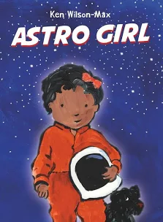  Astro Girl  Ken Wilson Max  Fact files about being  Astronauts Writing in role, commands, ‘how to’ guides
Spring 1 |  |  | Spring 2
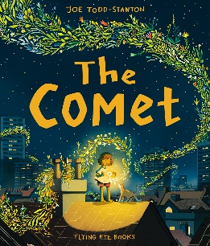  The Comet  Joe Todd Stanto  Own version narratives  Posters, letters of advice, poems, descriptions, writing in role, recipes | 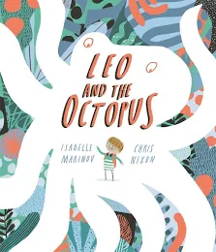  Leo and the  Octopus  Isabelle Marinov  Fact files-This is Me! posters, letters of  advice, factual descriptions,  logbooks, scripts |  | 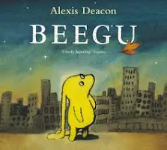  Beegu Alexis Deacon  Own version ‘alien’ narratives  Descriptions, commands,  letters, nonsense-word  dictionary, poems, non-fiction  reports |  | 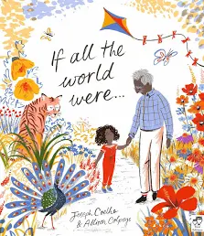 If All the World Were…  Joseph Coelho Non-narrative poems-Writing in role, diaries, letters  of advice, short explanations leaflets, list poems, dictionary of terms
Summer 1 |  |  | Summer 2
reports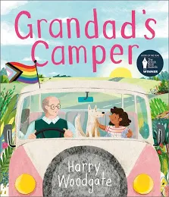  Grandad’s  Camper  Harry Woodgate Sequel narratives-Labels, memories poems,  interviews, photo album captions, postcards |  | 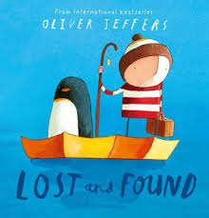  Lost and Found  Oliver Jeffers  Own version ‘losing/finding’ narratives  Character descriptions, retellings,  advice, instructions, non-chronological | 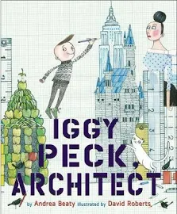  Iggy Peck, Architect Andrea Beaty and David Roberts  Fact files-Labels, captions, character  comparisons, thought and speech bubbles | 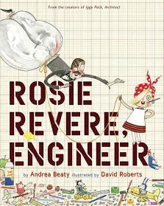  (If time) Rosie Revere,  Engineer Andrea Beaty Leaflet for local landmarks Short explanations, writing in role, reports, adverts

Text (Cycle A) | Narrative | Description | Diary | Poetry | Instructions | Recount | Persuasive | Letter | Leaflet | Poster | Non-Chron. Report
Cave Baby | ✔️ | ✔️ | ✔️ |  |  |  |  | ✔️
Naughty Bus | ✔️ | – | ✔️ |  |  | ✔️ |  | ✔️ |  |  | ✔️
Dear Earth |  |  |  | ✔️ | ✔️ |  | ✔️ | ✔️ | ✔️
Astro Girl |  |  |  |  | ✔️ |  |  |  |  |  | ✔️
The Comet | ✔️ | ✔️ | ✔️ | ✔️ | ✔️ | ✔️ |  | ✔️ |  | ✔️
Leo and the Octopus |  | ✔️ |  |  |  | ✔️ |  | ✔️ |  |  | ✔️
Beegu | ✔️ | ✔️ | ✔️ | ✔️ | ✔️ | ✔️ |  | ✔️ |  |  | ✔️
If All the World Were… |  |  | ✔️ | ✔️ | ✔️ | ✔️ |  | ✔️ | ✔️
Grandad’s Camper | ✔️ | ✔️ |  | ✔️ |  | ✔️
Lost and Found | ✔️ | ✔️ |  |  | ✔️ | ✔️ |  | ✔️ |  |  | ✔️
Iggy Peck, Architect |  | ✔️ |  |  |  |  |  |  |  |  | ✔️
Rosie Revere, Engineer |  |  |  |  | ✔️ |  | ✔️ |  | ✔️ |  | ✔️

Acorn – Literacy Tree Long Term Plan – Cycle B
Autumn 1 |  | Autumn 2
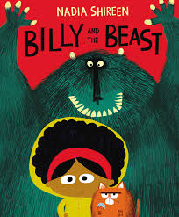 Billy and the Beast  Nadia Shireen Own version ‘defeat a monster’ Narratives Wanted posters, summaries, emails, character descriptions, recipes | 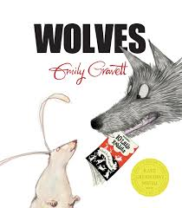  Wolves  Emily Gravett  Non-chronological leaflets  Captions, information writing, character descriptions and comparisons | 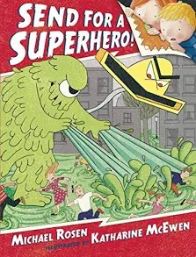  Send for a Superhero Michael Rosen & Katharine McEwan  Own version superhero narratives  Wanted posters, letters, speech bubbles, diaries, emails, character descriptions | 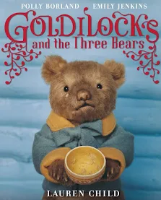  Goldilocks & the Three  Bears Lauren Child  Sequel stories-Wanted posters, letters, retellings from another point of view, lists of rules, character descriptions
Spring 1 |  | Spring 2
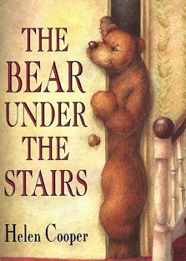  The Bear Under the Stairs  Helen Cooper  Information texts-Letters, retellings, own version narratives | 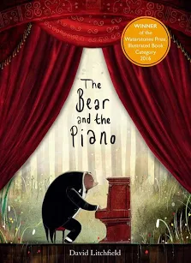  The Bear and the Piano David Litchfield  Own version narratives about bravery  Letters of advice, short news reports,  writing in role, retellings, information poster | 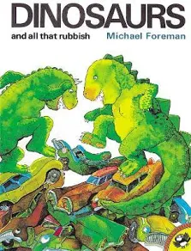 Dinosaurs and all that  Rubbish- Michael Foreman Pamphlets-Letters, setting descriptions, instructions, narrative retellings, pamphlets, posters | 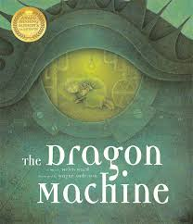  The Dragon Machine  Helen Ward  Own version dragon stories-Dragon guides & encyclopaedia, letters of advice, dragon machine explanations, shopping lists, descriptions, letters
Summer 1 |  | Summer 2
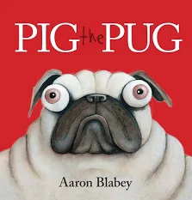  Pig the Pug  Aaron Blabey  How to be a Dog  Jo Williamson  ‘How to’ guides  Character comparisons, fact sheets,  shared poetry, own version narratives | 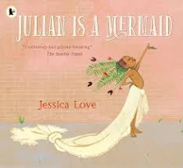  R Julian is a  Mermaid  Jessica Love  Three-verse poems  Instructions, writing in role,  advertisements | 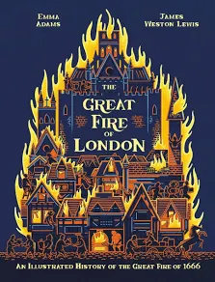  The Great Fire of  London Emma Adams Information booklets-Persuasive poster, warning posters, speech bubbles, letters of advice, certificates | 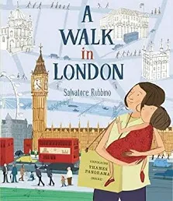  A Walk in London Salvatore  Rubbino  ‘A Walk in…’ tour guide  Instructions, persuasive  poster, setting descriptions,  captions, postcard, diary entry

Text (Cycle B) | Narrative | Description | Diary | Poetry | Instructions | Recount | Persuasive | Letter | Leaflet | Poster | Non-Chron. Report
Billy and the Beast | ✔️ | ✔️ |  |  | ✔️
Wolves |  | ✔️ |  |  |  |  |  |  | ✔️ |  | ✔️
Send for a Superhero | ✔️ | ✔️ | ✔️ |  |  | ✔️ |  | ✔️
Goldilocks & the Three Bears (Lauren Child) | ✔️ | ✔️ |  |  |  | ✔️ |  | ✔️
The Bear Under the Stairs | ✔️ |  |  |  |  | ✔️ |  | ✔️ | ✔️ |  | ✔️
The Bear and the Piano | ✔️ | ✔️ | ✔️ |  |  | ✔️ | ✔️ | ✔️ | ✔️ | ✔️
Dinosaurs and All That Rubbish | ✔️ | ✔️ |  |  | ✔️ | ✔️ |  | ✔️ | ✔️ | ✔️
The Dragon Machine | ✔️ | ✔️ | ✔️ |  | ✔️ |  |  | ✔️ | ✔️ |  | ✔️
Pig the Pug / How To Be a Dog | ✔️ | ✔️ |  | ✔️ | ✔️ |  |  |  |  |  | ✔️
Julian Is a Mermaid |  | ✔️ |  | ✔️ | ✔️ |  | ✔️
The Great Fire of London |  | ✔️ |  |  | ✔️ | ✔️ | ✔️ | ✔️ | ✔️ | ✔️ | ✔️
A Walk in London |  | ✔️ | ✔️ |  | ✔️ | ✔️ | ✔️ |  | ✔️ | ✔️

