Oak Class – Literacy Tree Long Term Plan – Cycle A
Autumn 1- |  | Autumn 2
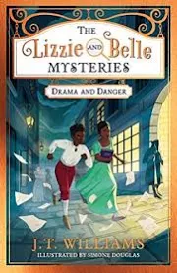  The lizzie and belle mysteries by J.T. Williams  Biographies Posters, diary  entries, case notes, letters,  character descriptions, fact  files, persuasive speeches | 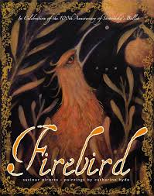  Firebird Saviour Pirotta and Catherine Hyde  Fairytale narratives Formal letters, retellings,  character descriptions | 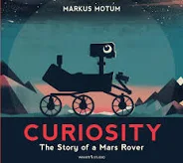  Curiosity Markus Motum  Expanded explanations  NASA Proposals, information  labels, short explanations,  NASA logs, news reports | 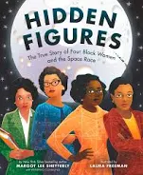 Hidden Figures Margot Lee Shetterly  Biographies-Diaries, journalistic writing, flashback narratives, speeches, discussions, letters, film critiques
Spring 1 |  | Spring 2
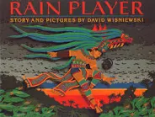  Rain Player David Wisniewski  Analytical essays about The Maya  Instructions, posters, missing scenes,  diaries, newspapers, debates |  | 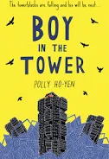  Boy in the Tower Polly Ho-Yen  Own version narratives (past and present tense) Journalistic writing, formal letters, nonchronological reports.
Summer 1 |  | Summer 2
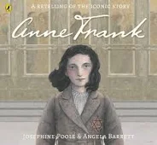  R Anne Frank Josephine Poole  Newspaper articles-Letters, short descriptions, extended diary entries, obituaries, opinion pieces |  | 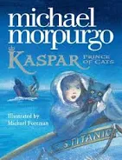  Kaspar, Prince of Cats Michael Morpurgo  Newspaper articles Character descriptions, reports, letters,  advertising leaflets, balanced reports

Oak Class – Literacy Tree Long Term Plan – Cycle B
Autumn 1 |  | Autumn 2
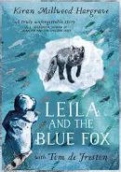 Leila and the Blue Fox Kiran Millwood Hargrave  Extended blog entry  Poetry, informal messages,  formal letters, short info texts,  diary entries, narrative / action  scenes, tweets | 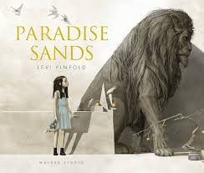  Paradise Sands Levi Pinfold  Narrative prequel- Descriptive story opening, informal note of advice, formal letter in role, descriptive retelling, conversation between characters, book review | 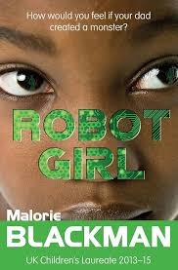  Robot Girl Malorie Blackman Science-fiction narratives  Discussions, debates, dialogue, character comparisons, reviews | 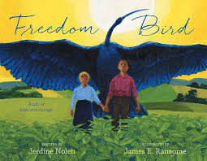  Winter’s Child  By Angela McAllister  Biographies Non-narrative  poems, explanations, dialogue,  postcards, letters of advice,  descriptions, recounts, narrative  poems
Spring 1 |  | Spring 2
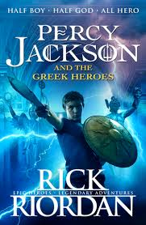  Percy Jackson Rick Riordan  Mythical narratives-Odes, soliloquies, setting descriptions, additional chapters, reports | 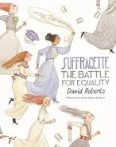  Suffragette: The Battle for  Equality David Roberts  Persuasive campaigns  Formal letters, diaries, balanced  arguments, speeches, short news  reports | 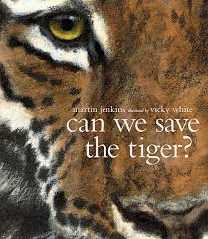  Can We Save the Tiger? Martin Jenkins  Discussion texts-Letters, explanations, persuasive posters,  & speeches, simple poems | 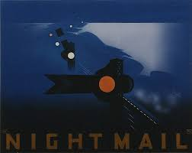  Night Mail W H Auden  Poetry  Letters, diaries, information leaflets,  instructions
Summer 1 |  | Summer 2
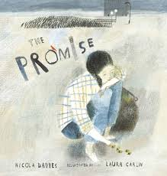  The Promise Nicola Davies or the island by Armin Greder  Narrative poem sequels-Promises, extended thought bubbles, diary entries, letters in role, figurative captions, summary poems |  | 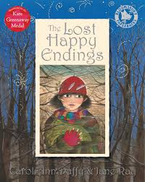  The Lost Happy Endings Carol Ann Duffy  Alternative perspective prequels - Newspaper reports, extended responses  to a text

Text | Narrative | Prequel | Alt/Sequel | Poetry | Description | Recount | Explanation | Instruction | Persuasive | Speech | Discussion/Debate | Reports | Formal/informal Letter | Bio/Obit | Review | Script | Info/Facts | Blog
Lizzie & Belle Mysteries | ✔️ |  |  |  | ✔️ | ✔️ |  |  | ✔️ | ✔️ |  | ✔️ | ✔️ | ✔️ |  |  | ✔️
Firebird | ✔️ |  |  |  | ✔️ |  |  |  |  |  |  |  | ✔️
Curiosity |  |  |  |  |  | ✔️ | ✔️ |  |  |  |  | ✔️ |  |  |  |  | ✔️
Hidden Figures | ✔️ |  |  |  |  | ✔️ |  |  |  | ✔️ | ✔️ | ✔️ | ✔️ | ✔️ | ✔️
Rain Player | ✔️ |  |  |  |  | ✔️ |  | ✔️ |  |  | ✔️ | ✔️
Boy in the Tower | ✔️ |  |  |  |  | ✔️ |  |  |  |  |  | ✔️ | ✔️ |  |  |  | ✔️
Anne Frank |  |  |  |  | ✔️ | ✔️ |  |  | ✔️ | ✔️ |  | ✔️ | ✔️ | ✔️
Kaspar, Prince of Cats |  |  |  |  | ✔️ | ✔️ |  |  |  |  | ✔️ | ✔️ | ✔️
Leila and the Blue Fox | ✔️ |  |  | ✔️ |  | ✔️ |  |  |  |  |  | ✔️ | ✔️ |  |  |  | ✔️ | ✔️
Paradise Sands | ✔️ | ✔️ |  |  | ✔️ |  |  |  |  |  |  |  | ✔️ |  | ✔️
Robot Girl | ✔️ |  |  |  | ✔️ |  |  |  |  |  | ✔️ |  |  |  | ✔️ | ✔️
Winter’s Child (Cycle B) | ✔️ |  |  | ✔️ | ✔️ | ✔️ | ✔️ |  |  |  |  |  | ✔️ | ✔️ |  | ✔️ | ✔️
Percy Jackson | ✔️ |  | ✔️ | ✔️ | ✔️ |  |  |  |  |  |  | ✔️ |  |  |  | ✔️
Suffragette |  |  |  |  |  | ✔️ |  |  | ✔️ | ✔️ | ✔️ | ✔️ | ✔️
Can We Save the Tiger? | ✔️ |  |  | ✔️ |  |  | ✔️ |  | ✔️ | ✔️ | ✔️ |  |  |  |  |  | ✔️
Night Mail |  |  |  | ✔️ |  | ✔️ |  | ✔️ |  |  |  | ✔️ |  |  |  |  | ✔️
The Promise / The Island | ✔️ |  | ✔️ | ✔️ | ✔️ | ✔️ |  |  |  |  |  |  | ✔️ | ✔️
The Lost Happy Endings | ✔️ | ✔️ | ✔️ |  |  | ✔️ |  |  |  |  |  | ✔️

