Sapling Class Long Term Plan Reading
Cycle 1
Autumn 1- Rainforest | Autumn 2- World War Two
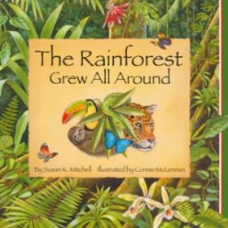  The Rainforest Grew All Around by Susan K Mitchell (2 Weeks) TH Fiction Skills:  -Retrieve and record information/ identify key details from fiction and non-fiction.  -Give/explain the meaning of words in context.  -Identify/explain how information/ narrative content is related and contributes to meaning as a whole.  -Identify/explain how meaning is enhanced through choice of words and phrases.  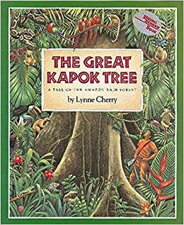  The Great Kapok Tree by Lynne Cherry (1 Weeks) – Link to Literacy/writing as well. TH Fiction Skills:  -Predict what might happen from details stated and implied.  -Retrieve and record information/ identify key details from fiction and non-fiction.  -Summarise main ideas from more than one paragraph  -Make inferences from the text/ explain and justify inferences with evidence from the text.  -Identify/explain how meaning is enhanced through choice of words and phrases.  -Identify/explain how meaning is enhanced through choice of words and phrases.  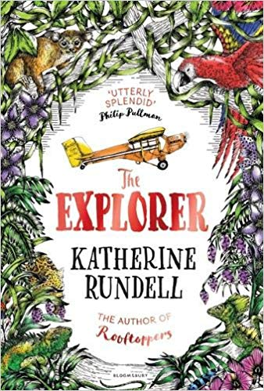  The Explorer by Katherine Rundell (2 weeks) Files Fiction Skills:  -Retrieve and record information/ identify key details from fiction and non-fiction.  -Make inferences from the text/ explain and justify inferences with evidence from the text.  -Identify/explain how information/narrative content is related and contributes to meaning as a whole.  -Identify/explain how meaning is enhanced through choice of words and phrases.  Reading for Pleasure Class Book Ideas  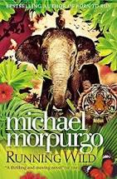  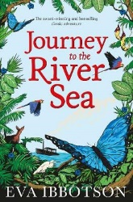  Journey to the River Sea- By Eva Ibbotson  Running Wild- Michael Morpurgo | 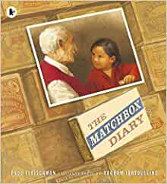  The Matchbox Diary By Paul Fleischman (3 Weeks) TH Fiction Skills:  -Give/explain the meaning of words in context.  -Retrieve and record information/ identify key details from fiction and non-fiction    -Make inferences from the text/ explain and justify inferences with evidence from the text.  - Identify/explain how meaning is enhanced through choice of words and phrases.  - Make comparisons within the text.    The River by Valerie Bloom and River Runs Free by David Windle (2 Weeks) TH Poetry Skills:  -Give/explain the meaning of words in context.  -Retrieve and record information/ identify key details from fiction and non-fiction.  -Make inferences from the text/ explain and justify inferences with evidence from the text.  -Identify/explain how information/narrative content is related and contributes to meaning as a whole.  - Identify/explain how meaning is enhanced through choice of words and phrases.  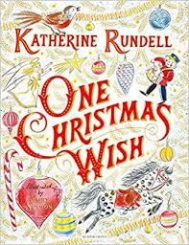  One Christmas Wish By Katherine Rundell (Literacy Shed) 1 Week Fiction Skills:  -Give/explain the meaning of words in context.  -Make inferences from the text/ explain and justify inferences with evidence from the text.  -Predict what might happen from details stated and implied.  -Identify/explain how information/narrative content is related and contributes to meaning as a whole.  -Retrieve and record information/ identify key details from fiction and non-fiction.  -Summarise main ideas from more than one paragraph.  Reading for Pleasure Class Book Ideas  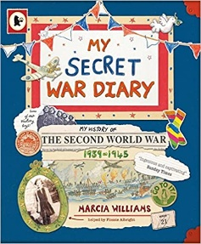  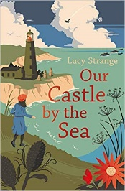  Our Castle by the Sea by Lucy Strange  My Secret War Diary by Marcia Williams
Spring 1- Viking | Spring 2- Viking
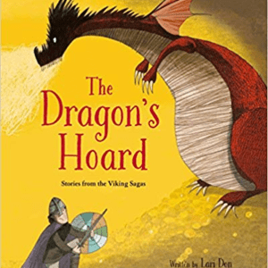  The Dragon’s Hoard by Lori Don (3 Weeks) TH Folklore Fiction Skills:  -Identify/explain how meaning is enhanced through choice of words and phrases.  -Make inferences from the text/ explain and justify inferences with evidence from the text.  -Retrieve and record information/ identify key details from fiction and non-fiction.  -Give/explain the meaning of words in context.  Anglo-Saxon Boy by Tony Bradman (4 Weeks) TH Historical Fiction Skills:  -Retrieve and record information/ identify key details from fiction and non-fiction.  -Give/explain the meaning of words in context.  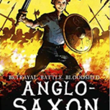  -Make inferences from the text/ explain and justify inferences with evidence from the text.  -Identify/explain how information/narrative content is related and contributes to meaning as a whole.  -Identify/explain how meaning is enhanced through choice of words and phrases.  -Predict what might happen from details stated and implied.  Reading for Pleasure Class Book Idea  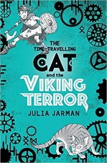  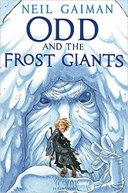  The Time-Travelling Cat and the Viking Terror by Julia Jarman  Odd and the Frost Giants by Neil Gaiman | 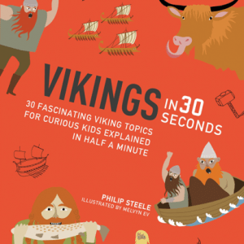  Vikings in 30 seconds’ by Philip Steele (2 Weeks) TH Non-Fiction Skills:  -Summarise main ideas from more than one paragraph.  -Retrieve and record information/ identify key details from fiction and non-fiction.  -Give/explain the meaning of words in context.  -Make inferences from the text/ explain and justify inferences with evidence from the text.  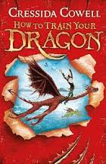  How to Train your Dragon by Cressida Cowell (Literacy Shed) 4 Weeks Fantasy Fiction Skills:  -Give/explain the meaning of words in context.  -Make inferences from the text/ explain and justify inferences with evidence from the text.  -Predict what might happen from details stated and implied.  -Identify/explain how information/narrative content is related and contributes to meaning as a whole.  -Retrieve and record information/ identify key details from fiction and non-fiction.  Summarise main ideas from more than one paragraph.  Reading for Pleasure Class Book Ideas  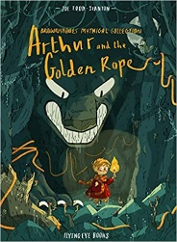  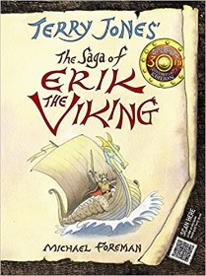  The Saga of Erik the Viking By Terry Jones  Arthur and the Golden Rope by Joe Todd Stanton
Summer 1- Extreme Earth | Summer 2- Ancient Egypt
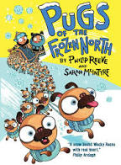  Pugs of The Frozen North by Philip Reeve and Sarah Mckintyre (Literacy Shed) 3 Weeks Fiction Skills:  -Make inferences from the text/ explain and justify inferences with evidence from the text.  -Predict what might happen from details stated and implied.  -Identify/explain how information/narrative content is related and contributes to meaning as a whole.  -Retrieve and record information/ identify key details from fiction and non-fiction.  -Summarise main ideas from more than one paragraph.  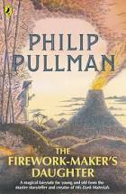  The Firework Maker’s Daughter by Philip Pullman (Literacy Shed) 3 Weeks Adventure Fiction Skills:  -Make inferences from the text/ explain and justify inferences with evidence from the text.  -Predict what might happen from details stated and implied.  -Identify/explain how information/narrative content is related and contributes to meaning as a whole.  -Retrieve and record information/ identify key details from fiction and non-fiction.  Summarise main ideas from more than one paragraph.  Reading for Pleasure Class Book Ideas  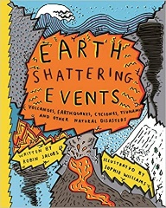  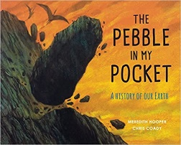  Earthshattering Events by Sophie Williams  The Pebble in my Pocket by Meredith Hooper | 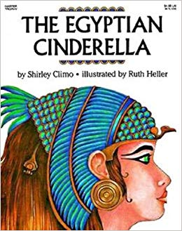  The Egyptian Cinderella By Shirley Climo  2 Weeks- Linked to Literacy Work Teaching Sparks Fiction Skills:  -Give/explain the meaning of words in context.  -Retrieve and record information/ identify key details from fiction and non-fiction.  -Summarise main ideas from more than one paragraph.  -Make inferences from the text/ explain and justify inferences with evidence from the text.  -Identify/explain how meaning is enhanced through choice of words and phrases.  SPAG: Clauses, speech, modifying verbs, past and present tense, word class and simile.  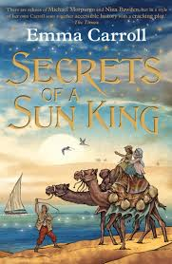  Secrets of a Sun King by Emma Carroll (1 Week) Teaching Sparks Fiction Skills:  -Give/explain the meaning of words in context.  -Retrieve and record information/ identify key details from fiction and -non-fiction.  -Summarise main ideas from more than one paragraph.  -Make inferences from the text/ explain and justify inferences with evidence from the text.  SPAG: spelling short I sound, inverted commas, past and present tense and synonyms.  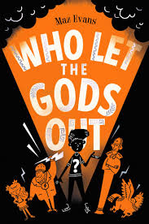  Who Let the Gods Out? By Maz Evans (Literacy Shed) 3 Weeks Fiction Skills:  -Make inferences from the text/ explain and justify inferences with evidence from the text.  -Predict what might happen from details stated and implied.  -Identify/explain how information/narrative content is related and contributes to meaning as a whole.  -Retrieve and record information/ identify key details from fiction and non-fiction.  -Summarise main ideas from more than one paragraph.  Reading for Pleasure Class Book Ideas  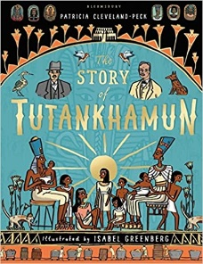  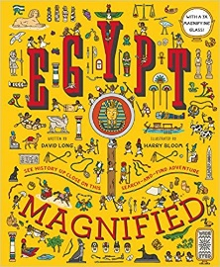  Egypt Magnified: With a 3x Magnifying Glass By David Long  The Story of Tutankhamun By Pactricia Cleveland-Peck
Cycle 2
Autumn 1- Stone Age | Autumn 2- Stone Age
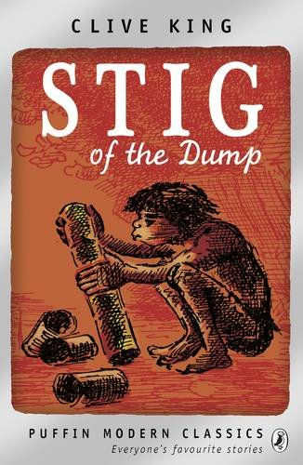  Stig of the Dump By Clive King (Twinkl) 4 Weeks Fiction Skills:  -Retrieve and record information/ identify key details from fiction and non-fiction.  -Make inferences from the text/ explain and justify inferences with evidence from the text.  -Identify/explain how information/narrative content is related and contributes to meaning as a whole.  -Identify/explain how meaning is enhanced through choice of words and phrases.  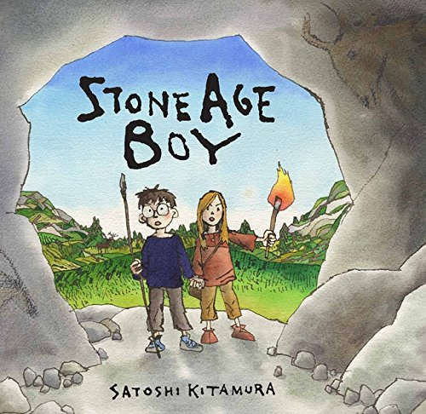  Stone Age Boy by Satoshi Kitamura (Literacy Shed) 3 Weeks Fiction Skills:  -Make inferences from the text/ explain and justify inferences with evidence from the text.  -Predict what might happen from details stated and implied.  -Identify/explain how information/narrative content is related and contributes to meaning as a whole.  -Retrieve and record information/ identify key details from fiction and non-fiction.  Summarise main ideas from more than one paragraph.  Reading for Pleasure Class Book Ideas  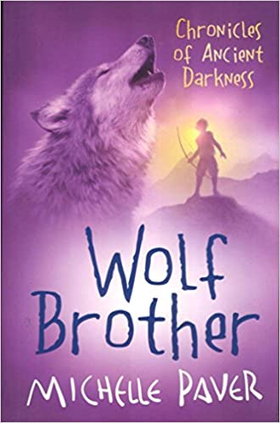  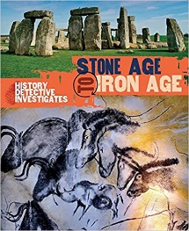  Stone Age to Iron Age by Clare Hibbert  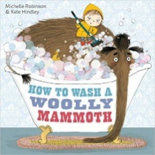  Wolf Brother by Michelle Paver  How to Wash a Woolly Mammoth by Michelle Robinson –Linked to Literacy | 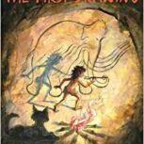  The First Drawing by Mordicai Gerstein (2 Weeks) WH Fiction Skills: -Make inferences from the text/ explain and justify inferences with evidence from the text.  -Give/explain the meaning of words in context.  -Predict what might happen from details stated and implied.    -Identify/explain how information/narrative content is related and contributes to meaning as a whole.  The Woolly Mammoth (1 Week) WH-Non Fiction Skills: -Summarise main ideas from more than one paragraph.  -Identify/explain how information/narrative content is related and contributes to meaning as a whole.  -Retrieve and record information/ identify key details from fiction and non-fiction.  -Give/explain the meaning of words in context.  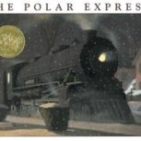  The Polar Express by Van Allsburg (2 Week) WH Fiction Skills: -Give/explain the meaning of words in context.  -Retrieve and record information/ identify key details from fiction and non-fiction.  -Make inferences from the text/ explain and justify inferences with evidence from the text.  -Identify/explain how information/narrative content is related and contributes to meaning as a whole.  -Identify/explain how meaning is enhanced through choice of words and phrases.  -Make comparisons within the text.  Reading for Pleasure Class Book Ideas  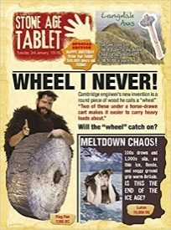  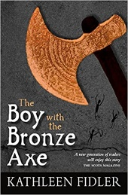  The Boy with the Bronze Axe by Kathleen Fidler  The Stone Age Tablet by Andrew Langley
Spring 1- Around the World | Spring 2- Around the World
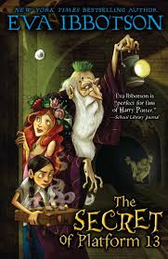  The Secret of Platform 12 By Eva Ibbotson (Literacy Shed) 3 Weeks Fiction Skills:  -Make inferences from the text/ explain and justify inferences with evidence from the text.  -Predict what might happen from details stated and implied.  -Identify/explain how information/narrative content is related and contributes to meaning as a whole.  -Retrieve and record information/ identify key details from fiction and non-fiction.  Summarise main ideas from more than one paragraph.  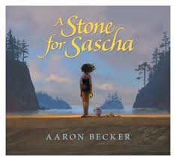  A Stone for Sascha by Aaron Becker- Linked to Literacy WH (4 Weeks) Fiction Skills:  -Give/explain the meaning of words in context.  -Make inferences from the text/ explain and justify inferences with evidence from the text.  -Identify/explain how information/narrative content is related and contributes to meaning as a whole.  -Retrieve and record information/ identify key details from fiction and non-fiction.  -Summarise main ideas from more than one paragraph.  -Predict what might happen from details stated and implied.  Reading for Pleasure Class Book Ideas  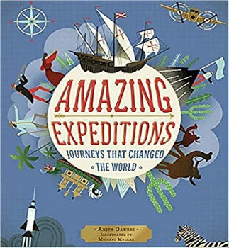  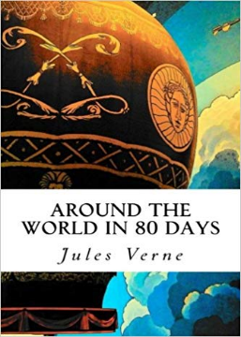  Around the World in 80 Days by Jules Verne  Amazing Expeditions by Anita Ganeri | The Lost Words by Jackie Morris (2 Weeks) Files Poetry Skills:  -Give/explain the meaning of words in context.  -Retrieve and record information/ identify key details from fiction and non-fiction.  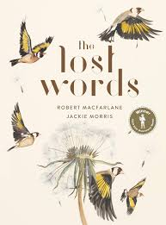  -Make inferences from the text/ explain and justify inferences with evidence from the text.  -Identify/explain how information/narrative content is related and contributes to meaning as a whole.  -Identify/explain how meaning is enhanced through choice of words and phrases.  Make comparisons within the text.  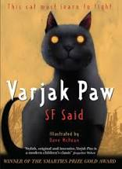  Varjak Paw by SF Said (2 Weeks) Literacy Shed Fiction Skills:  -Make inferences from the text/ explain and justify inferences with evidence from the text.  -Predict what might happen from details stated and implied.  -Identify/explain how information/narrative content is related and contributes to meaning as a whole.  -Retrieve and record information/ identify key details from fiction and non-fiction.  Summarise main ideas from more than one paragraph.  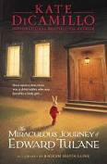  Miraculous Journey by Edward Tulane (Literacy Shed) 2 Weeks Fiction Skills:  -Make inferences from the text/ explain and justify inferences with evidence from the text.  -Predict what might happen from details stated and implied.  -Identify/explain how information/narrative content is related and contributes to meaning as a whole.  -Retrieve and record information/ identify key details from fiction and non-fiction.  Summarise main ideas from more than one paragraph.  Reading for Pleasure Class Book Ideas  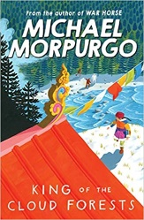  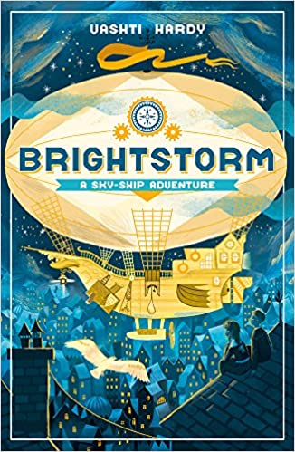  King of the Cloud Forests by Michael Morpurgo  Brightstorm: A Sky-Skip Adventure by Vashti Hardy
Summer 1- Romans | Summer 2- Romans
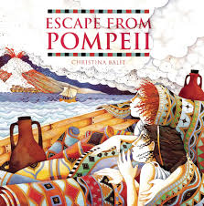  Escape from Pompeii by Christine Balit (1 Week) Teaching Sparks- Linked to Literacy Work Fiction/ Non Fiction (Newspaper) Skills:  -Give/explain the meaning of words in context.  -Retrieve and record information/ identify key details from fiction and non-fiction.  -Make inferences from the text/ explain and justify inferences with evidence from the text.  -Identify/explain how meaning is enhanced through choice of words and phrases.  SPAG: Apostrophes, past and present tense, comprehension and inverted commas.  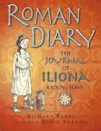  Roman Diary by Richard Platt (2 Weeks) WH Fiction Skills:  -Retrieve and record information/ identify key details from fiction and non-fiction.  -Identify/explain how information/narrative content is related and contributes to meaning as a whole.  -Identify/explain how meaning is enhanced through choice of words and phrases.  -Make comparisons within the text.  Give/explain the meaning of words in context.  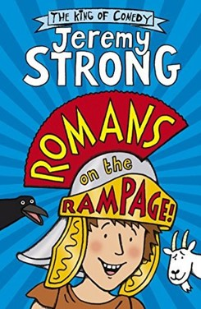  Romans on the Rampage by Jeremy Strong. (2 Weeks) WH Fiction Skills:  -Retrieve and record information/ identify key details from fiction and non-fiction.  -Identify/explain how information/narrative content is related and contributes to meaning as a whole.  -Identify/explain how meaning is enhanced through choice of words and phrases.  -Give/explain the meaning of words in context.  -Summarise main ideas from more than one paragraph.  -Predict what might happen from details stated and implied.  Imaginary Fred By Eoin Colfer (1 Week) Teaching Sparks Fiction Skills:  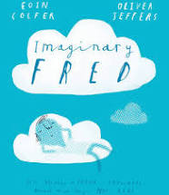  -Give/explain the meaning of words in context.  -Retrieve and record information/ identify key details from fiction and non-fiction.  -Identify/explain how meaning is enhanced through choice of words and phrases.  -Make inferences from the text/ explain and justify inferences with evidence from the text.  SPAG: Apostrophes, punctuation, inverted commas, spelling, homephones and word class.  Reading for Pleasure Class Book Ideas  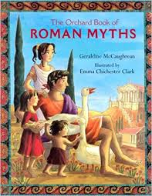  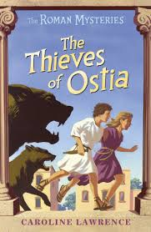  The Thieves of Ostia by Caroline Lawrence  The Orchard Book of Roman Myths by Geraldine McCaughrean and Emma Chinchester Clark | 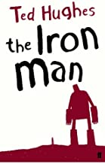  The Iron Man By Ted Hughes- 4 Weeks TH Fiction Skills:  -Give/explain the meaning of words in context.  -Retrieve and record information/ identify key details from fiction and non-fiction.  -Make inferences from the text/ explain and justify inferences with evidence from the text.  -Predict what might happen from details stated and implied.  -Identify/explain how information/narrative content is related and contributes to meaning as a whole.  -Identify/explain how meaning is enhanced through choice of words and phrases.  -Summarise main ideas from more than one paragraph.  -Make comparisons within the text.  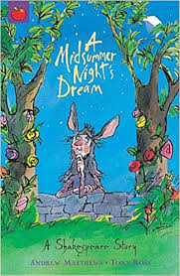  A Midsummer Night’s Dream: A Shakespeare Story by Andrew Matthews and Tony Ross (Literacy Shed) 1 Week Fiction Comedy Skills:  -Make inferences from the text/ explain and justify inferences with evidence from the text.  -Predict what might happen from details stated and implied.  -Identify/explain how information/narrative content is related and contributes to meaning as a whole.  -Retrieve and record information/ identify key details from fiction and non-fiction.  -Summarise main ideas from more than one paragraph.  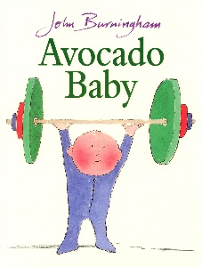  Avocado Baby by John Burningham- (Literacy Shed) 1 Week Picture Book Fiction Skills:  -Make inferences from the text/ explain and justify inferences with evidence from the text.  -Predict what might happen from details stated and implied.  -Identify/explain how information/narrative content is related and contributes to meaning as a whole.  -Retrieve and record information/ identify key details from fiction and non-fiction.  -Summarise main ideas from more than one paragraph  Reading for Pleasure Class Book Ideas  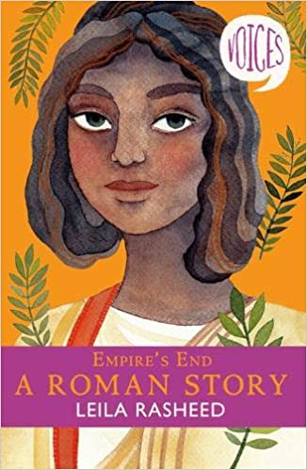  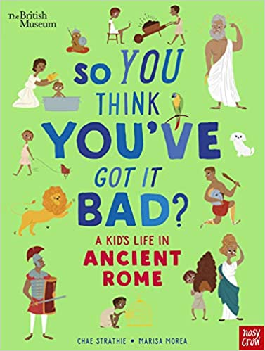  Empire’s End- A Roman Story by Leila Rasheed  So You Think You’ve Got It Bad: Ancient Rome by Chae Strathie

Cycle 1
Title of Book | 2a/2g Vocabulary | 2b Retrieval | 2c Summarise | 2d Inference | 2e Prediction | 2f Narrative content | 2h Compare | Visualise | Clarify | Question
The Rainforest Grew All Around | 
The Great Kapok Tree
The Explorer
The Matchbox Diary
The River
One Christmas
The Dragon’s Hoard
Anglo-Saxon Boy
Vikings in 30 Seconds
How to Train your Dragon
Pugs of The Frozen North
The Firework Maker’s Daughter
The Egyptian Cinderella
Secrets of a Sun King
Who Let the Gods Out?
Cycle 2
Title of Book | 2a/2g Vocabulary | 2b Retrieval | 2c Summarise | 2d Inference | 2e Prediction | 2f Narrative content | 2h Compare | Visualise | Clarify | Question
Stig of the Dump
Stone Age Boy
The First Drawing
The Woolly Mammoth
The Polar Express
The Secret of Platform 12
A Stone for Sascha
The Lost Words
Varjak Paw
Miraculous Journey of Edward Tulane
Escape from Pompeii
Roman Diary
Romans on the Rampage
Imaginary Fred
The Iron Man
A Midsummer Night’s Dream
Avocado Baby

