Oak Class Long Term Plan Reading
Non-Fiction Fiction Poetry Author Focus
Cycle 2
Autumn 1- Rivers | Autumn 2- Rivers
Journey to the River Sea - Eva Ibbotson (2 Weeks) TH Fiction Links to literacy unit Read and Respond. Skills:  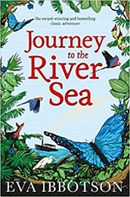  -Identify/explain how information/ narrative content is related and contributes to meaning as a whole.  -Identify/explain how meaning is enhanced through choice of words and phrases.  - Give/explain the meaning of words in context.  - Retrieve and record information/ identify key details from fiction and non-fiction.  - Summarise main ideas from more than one paragraph.  - Make inferences from the text/ explain and justify inferences with evidence from the text.  - Predict what might happen from details stated and implied.  - Make comparisons within the text.  Floodland - Marcus Sedgewick (4 weeks) LS Fiction Skills: Identify/explain how information/ narrative content is related and contributes to meaning as a whole.  - identify/explain how meaning is enhanced through choice of words and phrases.  - Give/explain the meaning of words in context.  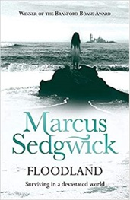  - Retrieve and record information/ identify key details from fiction and non-fiction.  - Summarise main ideas from more than one paragraph.  - Make inferences from the text/ explain and justify inferences with evidence from the text.  - Predict what might happen from details stated and implied.  - Make comparisons within the text.  Reading for Pleasure Class Book Ideas  Running Wild - Michael Morpurgo fiction  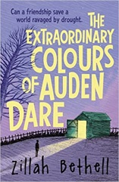  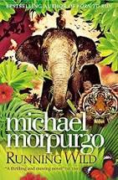  The Extraordinary Colours of Auden Dare - Zillah Bethell fiction | Kensuke’s Kingdom – Michael Morpurgo (2 Weeks) TH Fiction Links to literacy unit LS. Skills:  -Predict what might happen from details stated and implied.  -Retrieve and record information/ identify key details from fiction and non-fiction.  -Summarise main ideas from more than one paragraph  -Make inferences from the text/ explain and justify inferences with evidence from the text.  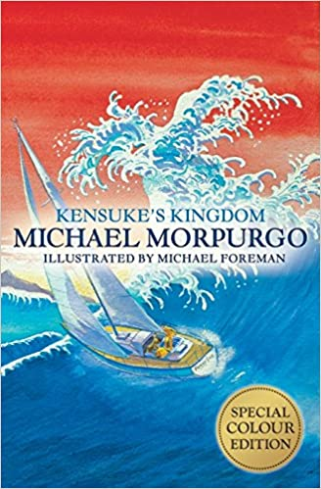  -Identify/explain how meaning is enhanced through choice of words and phrases.  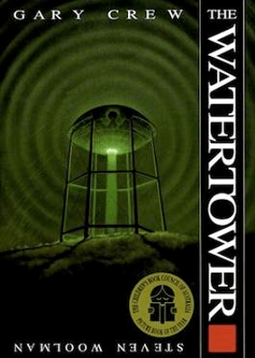  The Watertower by Gary Crew (2 Weeks) TH Fiction Skills:  -Identify/explain how meaning is enhanced through choice of words and phrases.  - Give/explain the meaning of words in context.  - Retrieve and record information/ identify key details from fiction and non-fiction.  - Summarise main ideas from more than one paragraph.  - Make inferences from the text/ explain and justify inferences with evidence from the text.  - Predict what might happen from details stated and implied.  - Make comparisons within the text.  Reading for Pleasure Class Book Ideas  Lost Tales – Adam Murphy fiction traditional tales  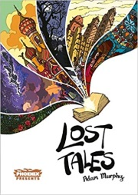  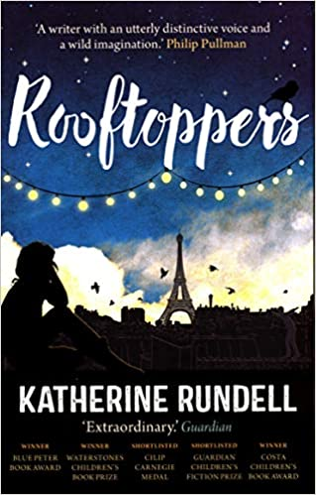  Roof Toppers – Katherine Rundell fiction
Spring 1- Crime and punishment | Spring 2- Crime and Punishment
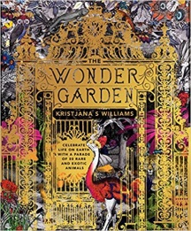  Holes – Louis Sachar (2 Weeks) TH Fiction Links to literacy unit LS.  Skills:  -Summarise main ideas from more than one paragraph.  -Retrieve and record information/ identify key details from fiction and non-fiction.  -Give/explain the meaning of words in context.  -Make inferences from the text/ explain and justify inferences with evidence from the text.  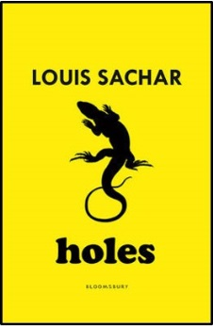  - Predict what might happen from details stated and implied.  The Wonder Garden – (5 weeks) Twinkl Non-fiction  - Give/explain the meaning of words in context.  - Retrieve and record information/ identify key details from fiction and non-fiction.  - Summarise main ideas from more than one paragraph.  - identify/explain how meaning is enhanced through choice of words and phrases.  Reading for Pleasure Class Book Idea  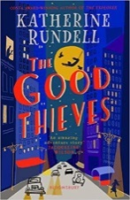  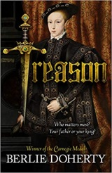  Treason - Berlie Doherty fiction  The Good Thieves - Katherine Rundell fiction | 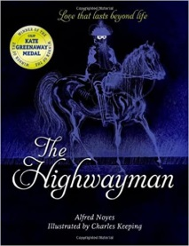  Highway Man – Alfred Noyes (1 week) Twinkl Poetry Skills: Links to Literacy unit Twinkl  - Give/explain the meaning of words in context.  -Make inferences from the text/ explain and justify inferences with evidence from the text.  - Predict what might happen from details stated and implied.  -Identify/explain how meaning is enhanced through choice of words and phrases.  Letters from the Lighthouse – Emma Carroll (2 Weeks) TH & LS Fiction Skills:  - Identify/explain how information/ narrative content is related and contributes to meaning as a whole.  -Identify/explain how meaning is enhanced through choice of words and phrases.  - Give/explain the meaning of words in context.  - Retrieve and record information/ identify key details from fiction and non-fiction.  - Summarise main ideas from more than one paragraph.  - Make inferences from the text/ explain and justify inferences with evidence from the text.  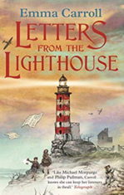  - Predict what might happen from details stated and implied.  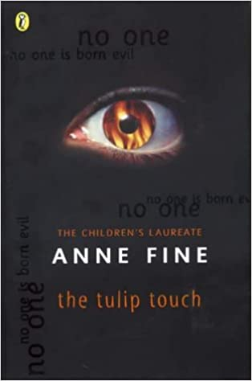  Reading for Pleasure Class Book Ideas  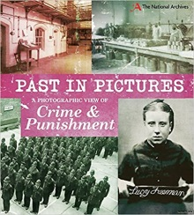  A Photographic View of Crime and Punishment (Past in Pictures) - Alex Woolf non-fiction  Tulip Touch – Anne Fine fiction
Summer 1- Ancient Greeks | Summer 2- Ancient Greeks
The 1000 Year Old Boy by Ross Welford (2 Weeks) TH Fiction Skills:  - Identify/explain how information/ narrative content is related and contributes to meaning as a whole.  -Identify/explain how meaning is enhanced through choice of words and phrases.  - Give/explain the meaning of words in context.  - Retrieve and record info  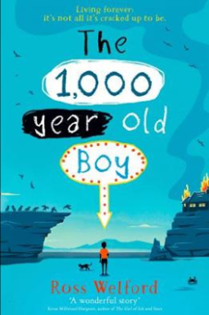  - Summarise main rmation/ identify key details from fiction and non-fiction. ideas from more than one paragraph.  - Make inferences from the text/ explain and justify inferences with evidence from the text.  - Predict what might happen from details stated and implied.  The Girl of Ink and Stars by Kiran Millwood Hargrave TH 2 Weeks Fiction LS Skills:  -Identify/explain how meaning is enhanced through choice of words and phrases.  - Give/explain the meaning of words in context.  - Retrieve and record information/ identify key details from fiction and non-fiction.  - Summarise main ideas from more than one paragraph.  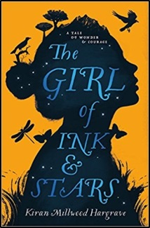  - Make inferences from the text/ explain and justify inferences with evidence from the text.  - Predict what might happen from details stated and implied  Reading for Pleasure Class Book Ideas  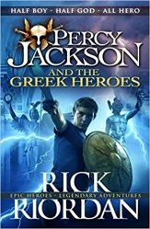  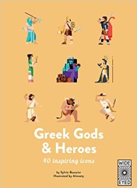  Greek Gods and Heros - Sylvie Baussier & Almasty non-fiction  Percy Jackson and the Greek Heros – Rick Riordan fiction | 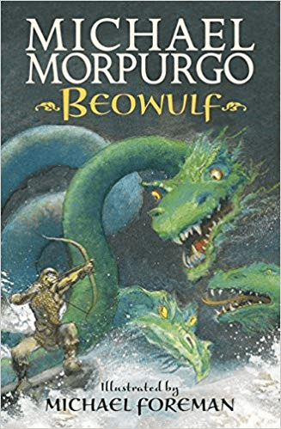  Beowulf by Michael Morpurgo ( Weeks 1 and 2) TH Historical Fiction Skills:  - Identify/explain how meaning is enhanced through choice of words and phrases.  - Give/explain the meaning of words in context.  - Retrieve and record information/ identify key details from fiction and non-fiction.  - Summarise main ideas from more than one paragraph.  - Make inferences from the text/ explain and justify inferences with evidence from the text.  - Predict what might happen from details stated and implied.  Beowulf by Michael Morpurgo ( Weeks 3 and 4) TH Historical Fiction Skills:  - Identify/explain how meaning is enhanced through choice of words and phrases.  - Give/explain the meaning of words in context.  - Retrieve and record information/ identify key details from fiction and non-fiction.  - Summarise main ideas from more than one paragraph.  - Make inferences from the text/ explain and justify inferences with evidence from the text.  - Predict what might happen from details stated and implied.  Reading for Pleasure Class Book Ideas  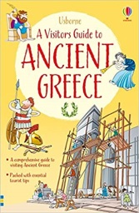  The Island at the End of Everything - Kiran Millwood Hargrave fiction  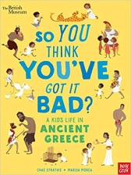  So You Think You’ve Got It Bad - Chae Strathie & Marisa Morea non-fiction  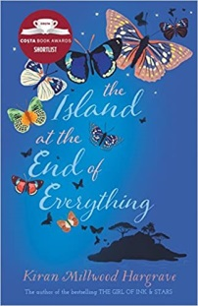  A Visitors Guide to Ancient Greece – Lesley Sims non-fiction
Cycle 1
Autumn 1- Chocolate and Mayans | Autumn 2- Chocolate and Mayans
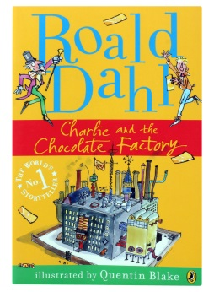  Charlie and the Chocolate Factory LS 4 Weeks Fiction Skills:  - Identify/explain how information/ narrative content is related and contributes to meaning as a whole.  -Identify/explain how meaning is enhanced through choice of words and phrases.  - Give/explain the meaning of words in context.  - Retrieve and record information/ identify key details from fiction and non-fiction.  - Summarise main ideas from more than one paragraph.  - Make inferences from the text/ explain and justify inferences with evidence from the text.  - Predict what might happen from details stated and implied.  - Make comparisons within the text.  Cosmic – Frank Cottrell Boyce LS Fiction  Skills:  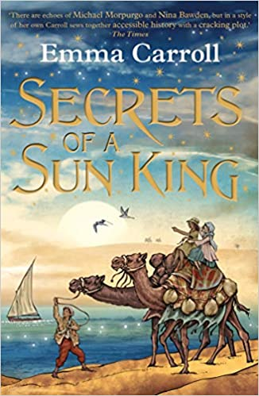  Secrets of a Sun King LS Weeks 1 and 2 Fiction Skills:  - Identify/explain how information/ narrative content is related and contributes to meaning as a whole.  -Identify/explain how meaning is enhanced through choice of words and phrases.  - Give/explain the meaning of words in context.  - Retrieve and record information/ identify key details from fiction and non-fiction.  - Predict what might happen from details stated and implied.  Reading for Pleasure Class Book Ideas  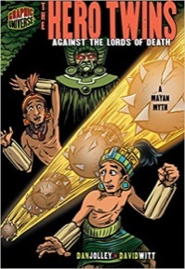  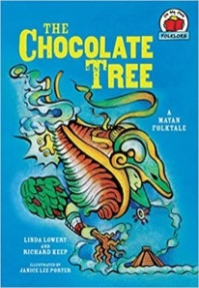  The Chocolate Tree – Linda Lowery fiction  Hero Twins – Against the Lords of Death – Dan Jolley fiction | Secrets of a Sun King (continued from Autumn 1) LS Weeks 3 and 4 Fiction Skills:  - Summarise main ideas from more than one paragraph.  - Make inferences from the text/ explain and justify inferences with evidence from the text.  - Make comparisons within the text.  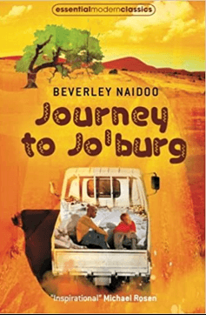  Journey to Jo’burg by Mordicai Gerstein (5 Weeks) TH Fiction Skills:    -- Identify/explain how information/ narrative content is related and contributes to meaning as a whole.  -Identify/explain how meaning is enhanced through choice of words and phrases.  - Give/explain the meaning of words in context.  - Retrieve and record information/ identify key details from fiction and non-fiction.  - Summarise main ideas from more than one paragraph.  - Make inferences from the text/ explain and justify inferences with evidence from the text.  - Predict what might happen from details stated and implied.  - Make comparisons within the text.  Reading for Pleasure Class Book Ideas  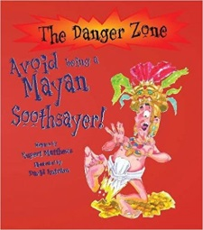  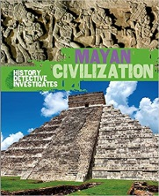  Avoid being a Mayan Soothsayer -  Rupert Mathews non-fiction  History Detective Investigates – Mayan Civilisation non-fiction
Spring 1- Indus Valley | Spring 2- Indus Valley
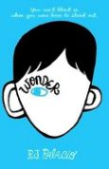  Wonder – R J Palacio Twinkl 6 Weeks Fiction Skills:  - Identify/explain how information/ narrative content is related and contributes to meaning as a whole.  -Identify/explain how meaning is enhanced through choice of words and phrases.  - Give/explain the meaning of words in context.  - Retrieve and record information/ identify key details from fiction and non-fiction.  - Summarise main ideas from more than one paragraph.  - Make inferences from the text/ explain and justify inferences with evidence from the text.  - Predict what might happen from details stated and implied.  - Make comparisons within the text.  Reading for Pleasure Class Book Ideas  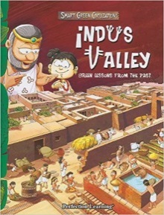  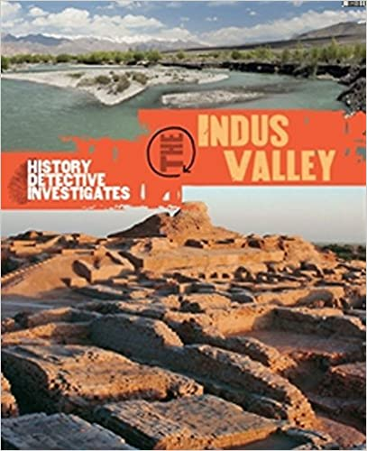  History Detective Investigates the Indus Valley – Claudia Martin non-fiction  Indus Valley: Green Lessons from the Past – Benita Sen non-fiction | 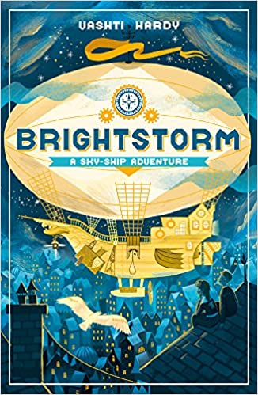  Brightstorm: A Sky-Skip Adventure - Vashti Hardy LS (5 Weeks) Fiction Skills:  -Give/explain the meaning of words in context.  -Retrieve and record information/ identify key details from fiction and non-fiction.  -Make inferences from the text/ explain and justify inferences with evidence from the text.  -Identify/explain how information/narrative content is related and contributes to meaning as a whole.  -Identify/explain how meaning is enhanced through choice of words and phrases.  Make comparisons within the text.  Reading for Pleasure Class Book Ideas  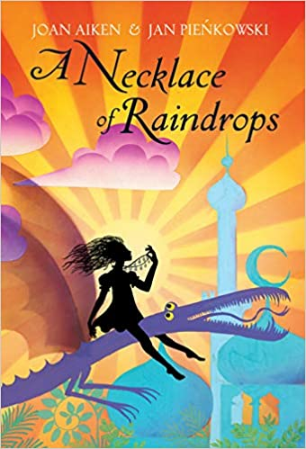  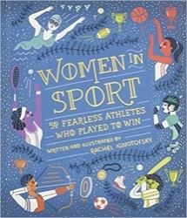  A Necklace of Raindrops – Joan Aitken and Jan Pienkowski fiction  Women in Sport Fifty Fearless Athletes Who Played to Win – Rachel Ignotofsky non-fiction
Summer 1- Local History | Summer 2- Local History
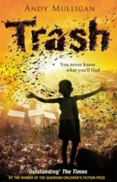  Trash by Andy Mulligan (2 Weeks) TH Fiction Skills:  Year 5 only, Year 6 focus on reading comprehension test practise  - identify/explain how information/ narrative content is related and contributes to meaning as a whole.  -Identify/explain how meaning is enhanced through choice of words and phrases.  - Give/explain the meaning of words in context.  - Retrieve and record information/ identify key details from fiction and non-fiction.  - Summarise main ideas from more than one paragraph.  - Make inferences from the text/ explain and justify inferences with evidence from the text.  - Predict what might happen from details stated and implied.  - Make comparisons within the text.  Cogheart – Peter Bunzl (2 Weeks) TH Fiction  -Give/explain the meaning of words in context.  -Retrieve and record information/ identify key details from fiction and non-fiction.  -Make inferences from the text/ explain and justify inferences with evidence from the text.  -Identify/explain how information/narrative content is related and contributes to meaning as a whole.  -Summarise main ideas from more than one paragraph.  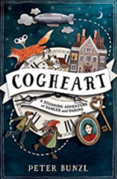  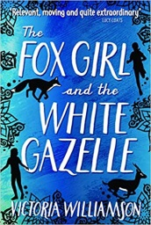  Reading for Pleasure Class Book Ideas  Overheard in a Tower Block – Joseph Coelho poetry  Fox Girls and the White Gazelle – Vitoria Williams fiction  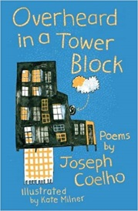 | Macbeth - 6 Weeks Twinkl and LS Author Focus Skills: Linked to literacy and Oak Class performance  -Give/explain the meaning of words in context.  -Retrieve and record information/ identify key details from fiction and non-fiction.  -Make inferences from the text/ explain and justify inferences with evidence from the text.  -Predict what might happen from details stated and implied.  -Identify/explain how information/narrative content is related and contributes to meaning as a whole.  -Identify/explain how meaning is enhanced through choice of words and phrases.  -Summarise main ideas from more than one paragraph.  -Make comparisons within the text.  OR  Tempest - 6 Weeks Twinkl and LS Author Focus Skills: Linked to literacy and Oak Class performance  -Give/explain the meaning of words in context.  -Retrieve and record information/ identify key details from fiction and non-fiction.  -Make inferences from the text/ explain and justify inferences with evidence from the text.  -Predict what might happen from details stated and implied.  -Identify/explain how information/narrative content is related and contributes to meaning as a whole.  -Identify/explain how meaning is enhanced through choice of words and phrases.  -Summarise main ideas from more than one paragraph.  -Make comparisons within the text.  Reading for Pleasure Class Book Ideas  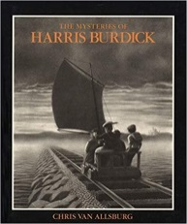  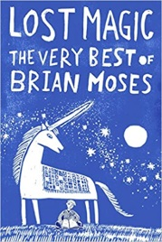  Lost Magic the very best of Brian Moses – Poetry collection poetry  The Mysteries of Harris Burdick –  Chris Van Allsburg fiction picture stimulus

Cycle 1
Title of Book | 2a/2g Vocabulary |  | 2b Retrieval | 2c Summarise | 2d Inference | 2e Prediction | 2f Narrative content | 2h Compare | Visualise | Clarify | Question
Charlie and the Chocolate Factory | 
Secrets of the Sun King
Journey to Jo’Burg
Wonder
Bright Storm
Trash
Cogheart
Macbeth
Tempest
Cycle 2
Title of Book |  | 2a/2g Vocabulary | 2b Retrieval | 2c Summarise | 2d Inference | 2e Prediction | 2f Narrative content | 2h Compare | Visualise | Clarify | Question
Journey to the River Sea
Floodland
Kensuke’s Kingdom
The Watertower
Holes
The Wonder Garden
The Highwayman
Letters from the Lighthouse
1000 Year Old Boy
The Girl of Ink and Stars
Beowulf
Beowulf

