Long Term Plan- Reading
Reception

What should they know from EYFS in Reading that will be built on in KS1?
Children read and understand simple sentences. They use phonic knowledge to decode regular words and read them aloud accurately. They also read some common irregular words. They demonstrate understanding when talking with others about what they have read.
Non-Fiction Fiction Poetry Author Focus
*Once we have read the story put it into the reading area for independent reading.

Whole Class Reading
Autumn |  | Spring | Summer
Magnificent Me |  | Food Glorious Food | Growing/Minibeasts
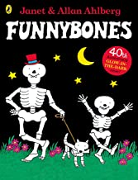  Funny Bones  Janet and Allan Ahlberg TES  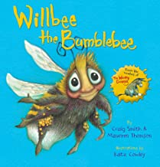  Willbee the Bumblebee  Craig Smith TH  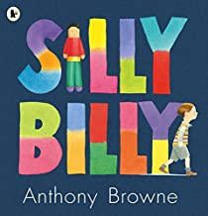  Silly Billy  Anthony Browne TH  *Predict what might happen on the basis of what has been.  *Identify and explain key aspects of fiction and non-fiction text, such as characters, events, titles and information.  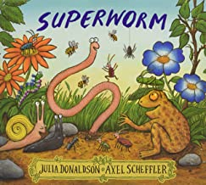  Superworm  Julia Donaldson TES  Dinosaurs Non-fiction  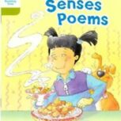  Senses Poems TH  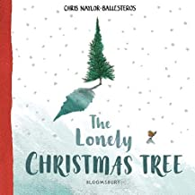  The Lonely Christmas Tree  Chris Naylor-Ballesteros TH |  | 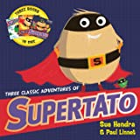 Supertato  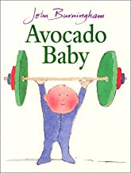  Avocado Baby John Burningham LS  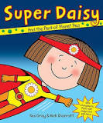  Super Daisy  Kes Gray TH  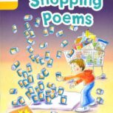  Shopping Poems TH  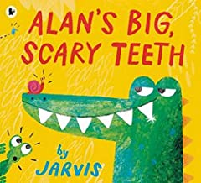  Alan’s Big Scary Teeth  Jarvis TH  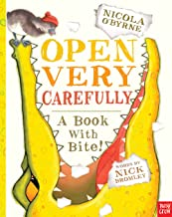  Open Very Carefully A Book with a Bite  Nick Bromley TH | 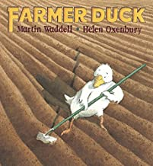  Farmer Duck  Martin Wadell TH  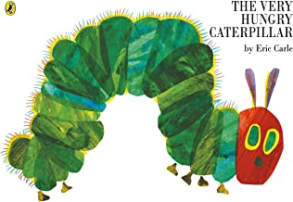  The Very Hungry Caterpillar  Eric Carle  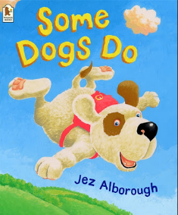  Some Dogs Do  Jez Alborough TH  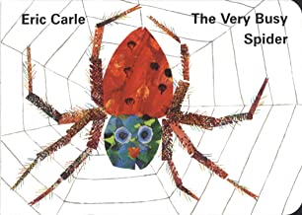  The Very Busy Spider  Eric Carle TH  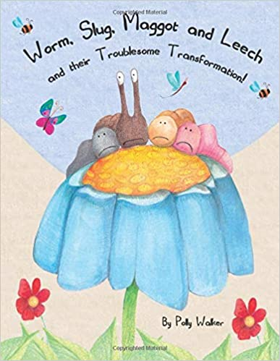  Worm, Slug, Maggot & Leech & their Troublesome Transformation!  Polly Walker TH  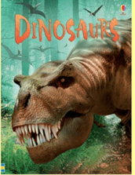  Dinosaurs  Usbourne Books TH  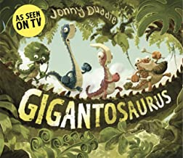  The Gigantosaurus  Jonny Duddle TH
Reading for Pleasure-Class Books
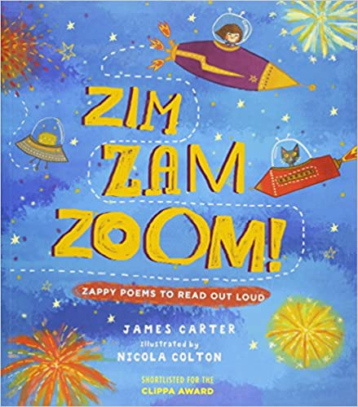  James Carter Zim, Zam, Zoom  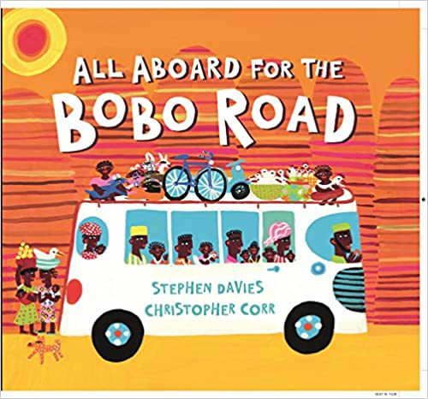  All Aboard for BoBo  Road  Stephen Davies  William Bee's Wonderful World of Tractors and Farm Machines  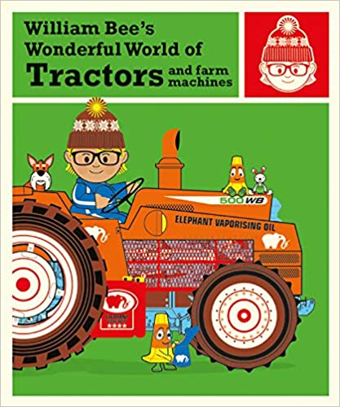  William Bee | 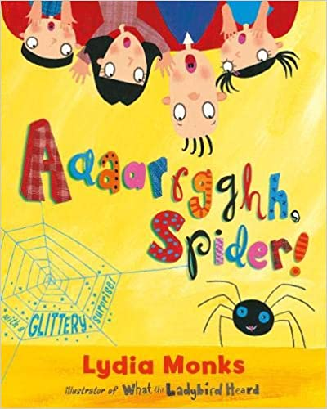  Aaarrghh Spider!  Lydia Monks  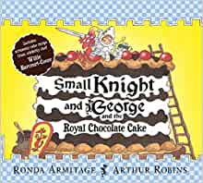  Small Knight and George and the Royal Chocolate Cake  Ronda Armitage  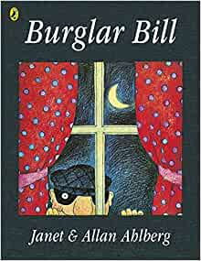  Burglar Bill  Janet & Allan Ahlberg  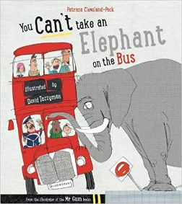  You Can’t Take an Elephant on the Bus  Patricia Cleveland Peck  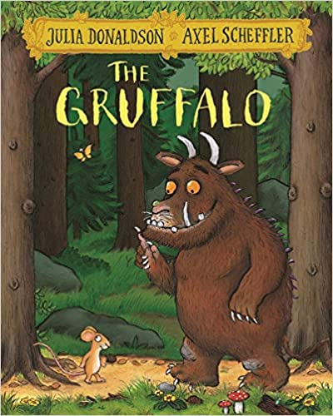  The Gruffalo  Julia Donaldson |  | 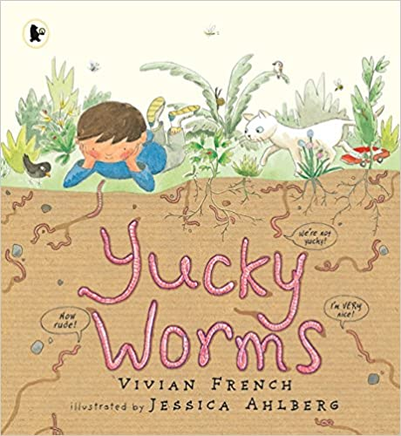  Yucky Worms  Vivian French  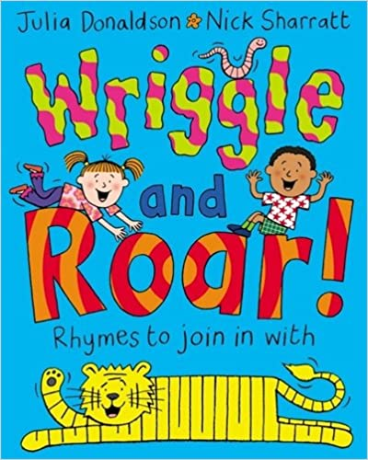  Wriggle and Roar  Julia Donaldson  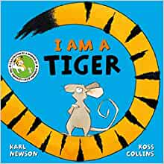  I am a Tiger  Karl Newsom  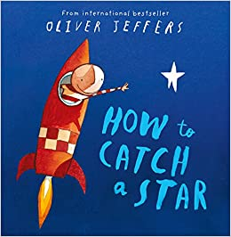  How to Catch a Star  Oliver Jeffers  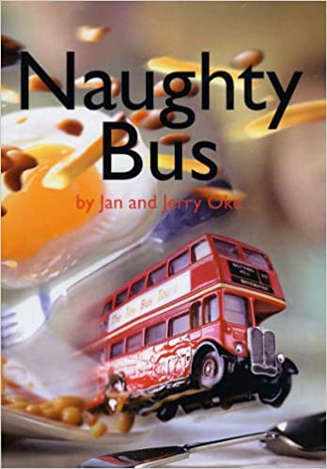  Naughty Bus

Cycle 2
Title of Book/Reading Domain or skill | 1a Vocabulary | 1b Retrieval | 1c Sequencing | 1d Inference | 1e Prediction | Visualise | Clarify | Question
Autumn
Funny Bones | 
Willbee the Bumblebee
Silly Billy
Superworm
Senses Poems
The Lonely Christmas Tree
Spring
Supertato
Avocado Baby
Super Daisy
Shopping Poems
Alan’s Big Scary Teeth
Open Very Carefully: A Book with a Bite
Summer
Farmer Duck
Some Dogs Do
The Very Hungry Caterpillar
The Very Busy Spider
Worm, Slug, Maggot & Leech & Their Troublesome Transformation!
Dinosaurs (Non-fiction)
The Gigantosaurus

