Long Term Plan- Reading
ACORN CLASS

What should they know from EYFS in Reading that will be built on in KS1?
Children read and understand simple sentences. They use phonic knowledge to decode regular words and read them aloud accurately. They also read some common irregular words. They demonstrate understanding when talking with others about what they have read.
Non-Fiction Fiction Poetry Author Focus
*Once we have read the story put it into the reading area for independent reading.
Cycle 1
Autumn | Spring | Summer
Seaside | Animals Great and Small | Explorers
ENTERTAIN  Pirates Next Door by Jonny Duddles Fiction  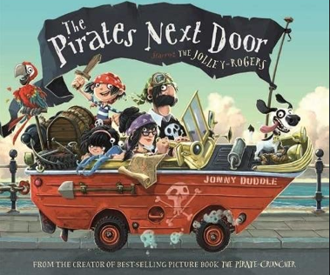  Skills:  *Draw on knowledge of  vocabulary  to understand texts.  *Identify and explain key  aspects of fiction and non-fiction text, such as characters, events, titles and information.  *Make inferences from the text.  *Predict what might happen on the basis of what has been.  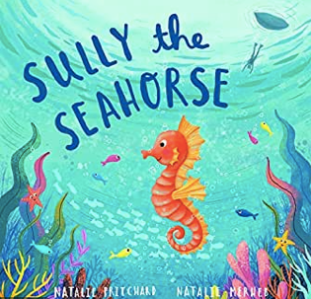  Author Focus Natalie Pritchard  Sully the Seahorse by Natalie Pritchard (Links to emotional intelligence and Geography) 3 weeks Fiction Poetry  Skills  *Make inferences from the text.  * Predict what might happen on the basis of what has been.  *Draw on what they already know or on background information and vocabulary.  Monty the Manatee by Natalie Pritchard. (Links to emotional intelligence, Geography, friendships and kindness) 3 weeks Narrative Poetry  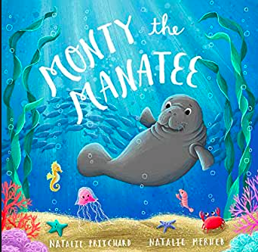  Skills:  *Make inferences from a text.  * Predict what might happen on the basis of what has been.  *Discuss and clarify the meaning of words.  *ask and answer questions  *Explain and discuss their understanding of the book.  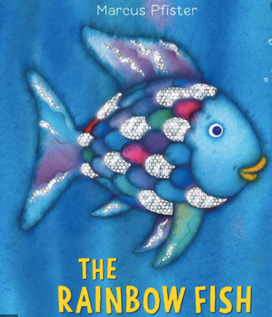  Rainbow Fish by Marcus Pfister Fiction (friendships). LS  Skills:  *Sequence the story and write captions.  *Draw on knowledge of vocabulary to understand texts.  *Identify and explain key aspects of fiction and non-fiction text, such as characters, events, titles and information.  * Identify and explain the sequence of events in texts.  * Predict what might happen on the basis of what has been.  The Storm Whale by Benji Davies Fiction (Friendship, loss and saying goodbye).  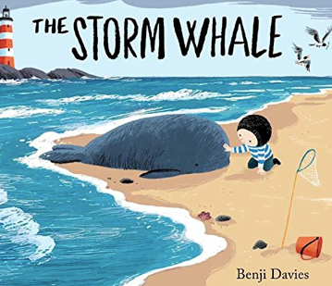  Skills:  *Draw on knowledge of vocabulary to understand texts.  *Sequence the story and write captions.  *Identify and explain key aspects of fiction and non-fiction text, such as characters, events, titles and information.  * Identify and explain the sequence of events in texts.  * Predict what might happen on the basis of what has been.  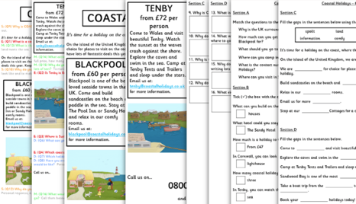  Coastal Holidays Non-fiction (Holiday Brochure) CS. Skills:  *Draw on knowledge of vocabulary to understand texts.  Identify and explain key aspects of fiction and non-fiction text, such as characters, events, titles and information  What would Christmas be without love? FILM Narrative Skills:  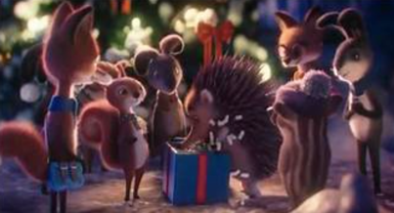  *Identify and explain the sequence of events in texts.  *Identify and explain key aspects of fiction and non-fiction text, such as characters, events, titles and information.  *Draw on knowledge of vocabulary to understand texts. | ENTERTAIN  Author Focus Emily Gravett  Meerkat Mail by Emily Gravett. Narrative Fiction (2 weeks)  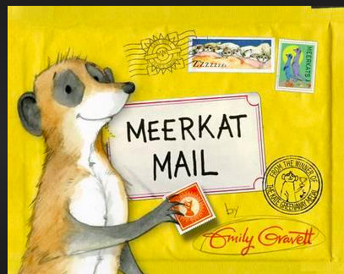  Skills:  *To infer information from a text.  * Draw on knowledge of  vocabulary  to understand texts.  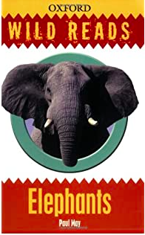  INFORM  Elephant (Wild Reads) by Paul May. Non-Fiction. (2 Week)  Skills:  *Find and Copy.  *To understand and use new vocabulary.  Farm Animals by Katie Daynes. Non-Fiction  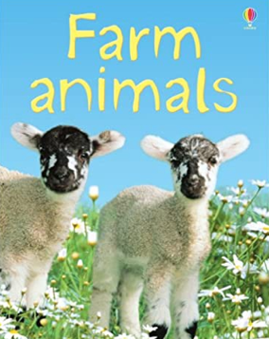  Skills:  * Identify and explain key aspects of fiction and non-fiction text, such as characters, events, titles and information.  * Identify and explain the sequence of events in texts.  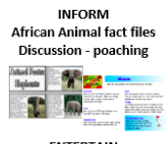  ENTERTAIN  Owl Babies by Martin Waddell’s Fiction  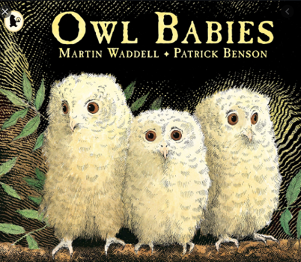  Skills:  *Write captions for characters based on what you have read.  *Sequence the story and write captions.  *Draw on knowledge of vocabulary to understand texts.  * Identify and explain the sequence of events in texts.  * Predict what might happen on the basis of what has been.  Handa’s surprise by Eileen Browne Fiction  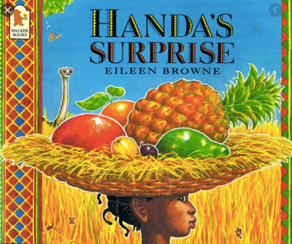  Skills:  *Identify and explain key aspects of fiction and non-fiction text, such as characters, events, titles and information.  *Predict what might happen on the basis of what has been read so far.  *Draw on knowledge of vocabulary to understand texts.  *Make inferences from the text.  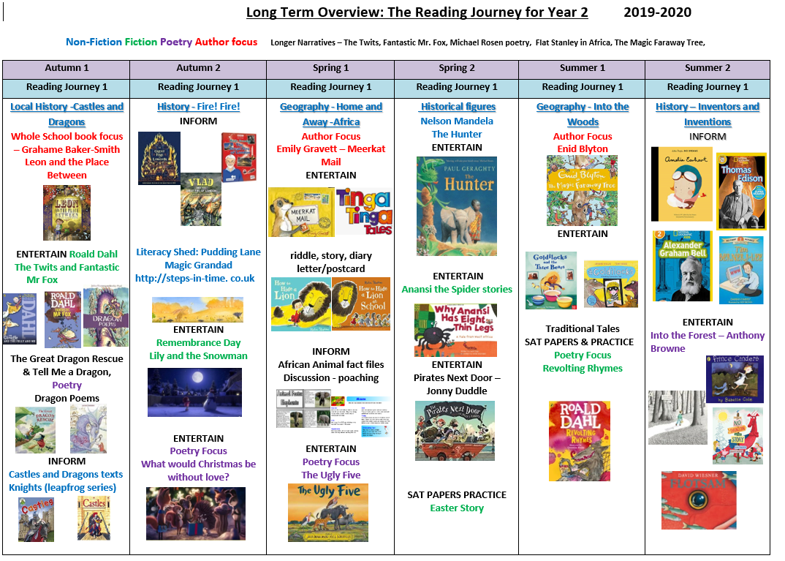  How to Hide a Lion & How to Hide a Lion at School by Helen Stephens Fiction  Skills:  *Draw upon knowledge of vocabulary to understand the text.  * Make inferences from the text.  (GD COMPARE STORIES)  The Ugly Five by Julia Donaldson Poetry  Skills:  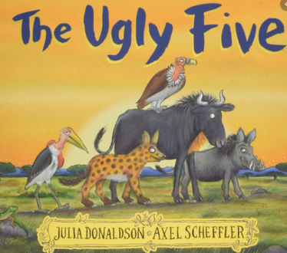  *Draw upon knowledge of vocabulary to understand the text.  * Make inferences from the text.  GD Compare story | INFORM  Amelia Earhart by Isabel Sanchez Vegara NON-FICTION (History and Geography Links)  Skills  *Discuss the sequence of events in books and how items of information are related.  *Discover non-fiction books that are structured in different ways.  *Make inferences from the text.  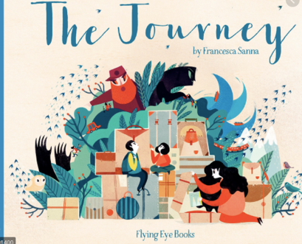  The Journey by Francesca Senna Fiction (Refugees) LS  Skills:  *Sequence the story and write captions.  *Draw on knowledge of vocabulary to understand texts.  *Identify and explain key aspects of fiction and non-fiction text, such as characters, events, titles and information.  * Identify and explain the sequence of events in texts.  * Predict what might happen on the basis of what has been.  ENTERTAIN  Lost and Found by Oliver Jeffers Fiction  Skills:  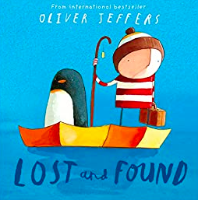  * Identify and explain key aspects of fiction and non-fiction text, such as characters, events, titles and information.  * Predict what might happen on the basis of what has been read so far.  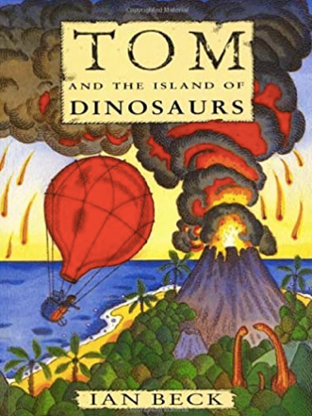  Tom and the Island of Dinosaurs by Ian Beck’s. (Adventure story) Fiction.  Skills:  * Make inferences from the text.  * Identify and explain key aspects of fiction and non-fiction text, such as characters, events, titles and information.  * Identify and explain the sequence of events in texts.  * Predict what might happen on the basis of what has been read so far.  The Dot by Peter H Reynolds (3 weeks) Fiction  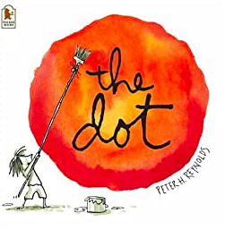  Skills: LS  *Draw on knowledge of vocabulary to understand texts.  *Sequence the story and write captions.  *Identify and explain key aspects of fiction and non-fiction text, such as characters, events, titles and information.  * Identify and explain the sequence of events in texts.  * Predict what might happen on the basis of what has been.  INFORM  Neil Armstrong  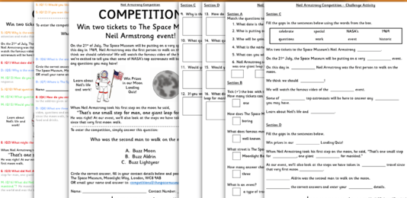  Fact File CS Non-Fiction  Skills:  *Draw on knowledge of vocabulary to understand texts.  *Identify and explain key aspects of fiction and non-fiction text, such as characters, events, titles and information.  The Smeds and the Smoos by Julia Donaldson Poetry (links with diversity and acceptance)  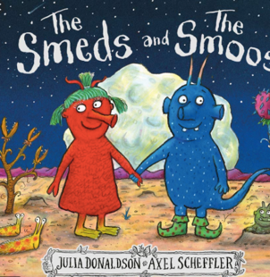  Skills:  * Predict what might happen on the basis of what has been.  *Identify and explain key aspects of fiction and non-fiction text, such as characters, events, titles and information.  *Identify and explain the sequence of events in texts.  *Draw upon knowledge of vocabulary to understand the text.
Reading for Pleasure-Class Books
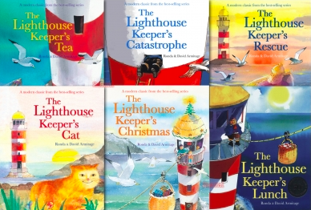  The lighthouse keeper’s Lunch by Ronda and David Armitage  The Lighthouse Keeper’s picnic by Ronda and David Armitage  The Lighthouse Keeper’s Christmas by Ronda and David Armitage  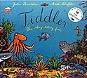  Tiddler  Julia Donaldson & Axel Scheffler  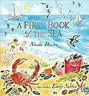  A First Book of the Sea  Nicola Davies & Emily Sutton  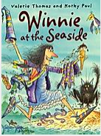  Winnie at the Seaside  Valerie Thomas | 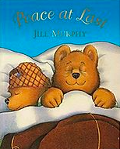  Peace at Last by Jill Murphy  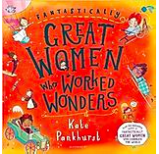  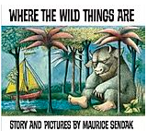  Great Women who Worked Wonders by Kate Pankhurst  Where the Wild Things Are by Maurice Sendak  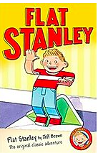  Flat Stanley by Jeff Brown & Rob Biddulph | 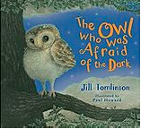  The Owl who was Afraid of the Dark by Jill Tomlinson  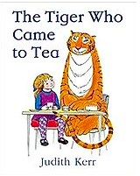  The Tiger Who Came to Tea by Judith Kerr  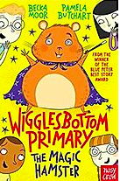  Wiggles Bottom Primary The Magic Hamster by Becca Moor

Cycle 1
Title of Book/Reading Domain or skill | 1a Vocabulary | 1b Retrieval | 1c Sequencing | 1d Inference | 1e Prediction | Visualise | Clarify | Question
Autumn
Pirates Next Door | 
Sully the Seahorse
Monty the Manatee
The Rainbow Fish
The Storm Whale
Coastal Holidays Brochure
What would Christmas be without love?
Spring
Meerkat Mail
Elephants
Farm Animals
Owl Babies
Handa’s Surprise
How to Hide a Lion
How to Hide a Lion at School
The Ugly Five
Summer
Amelia Earhart
The Journey
Lost and Found
Tom and the Dinosaurs
The Dot
Neil Armstrong
The Smeds and the Smoos

Cycle 2
Autumn |  | Spring | Summer
Enchanted Forest |  | Castles, knights, Kings, Queens and Dragons | Great Fire of London
ENTERTAIN  Little Red Riding Hood by Bev Evans. Fiction  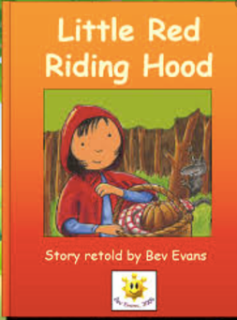  Skills:  * Identify and explain the sequence of events in texts.  * Make inferences from the text.  *Draw upon knowledge of vocabulary to understand the text.  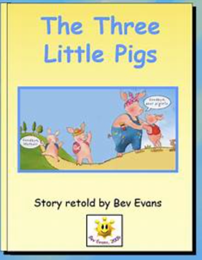  The Three Little Pigs by Bev Evans.  Skills:  * Identify and explain the sequence of events in texts.  *Draw upon knowledge of vocabulary to understand the text.  The Last Wolf by Mini Grey Fiction  Skills:  * Predict what might happen on the basis of what has been.  * Identify and explain key aspects of fiction and non-fiction text, such as characters, events, titles and information.  *Identify and explain the sequence of events in texts.*Draw upon knowledge of vocabulary to understand the text.  Good little Wolf by Nadia Shireen Fiction. (Links to good winning over bad).  Skills:  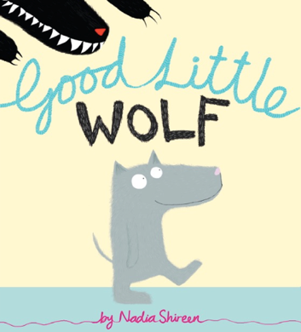  *Predict what might happen on the basis of what has been.  *Identify and explain key aspects of fiction and non-fiction text, such as characters, events, titles and information.  *Identify and explain the sequence of events in texts.  *Draw upon knowledge of vocabulary to understand the text.  *Ask and answer questions  INFORM  Remembrance Day CBeebies Film Non-Fiction  *Predict what might happen on the basis of what has been  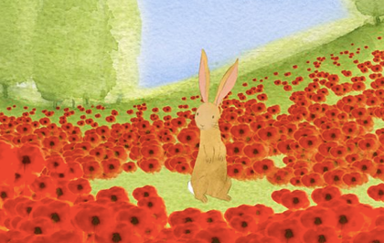  * Make inferences from the text.  *Draw upon knowledge of vocabulary to understand the text.  ENTERTAIN  The Tunnel by Anthony Browne Fiction. LS  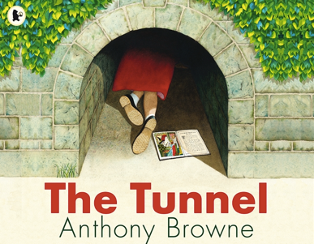  Skills:  *Predict what might happen on the basis of what has been.  *Identify and explain key aspects of fiction and non-fiction text, such as characters, events, titles and information.  *Identify and explain the sequence of events in texts.  *Draw upon knowledge of vocabulary to understand the text.  *Ask and answer questions  Bonfire Night Poems by Irene Yates in Special Days Poems book by John Foster. Poetry  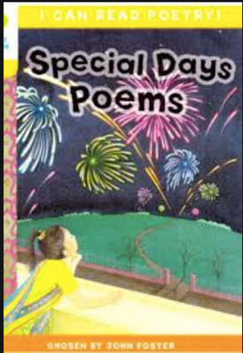  Skills: Retrieval and visualization  *Draw upon knowledge of vocabulary to understand the text.  * Identify and explain key aspects of fiction and non-fiction text, such as characters, events, titles and information.  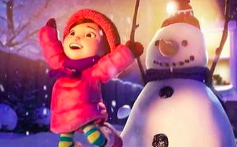  Lily and the Snowman by Literacy Shed Film  Skills:  *Predict what might happen on the basis of what has been.  *Identify and explain key aspects of fiction and non-fiction text, such as characters, events, titles and information.  *Draw upon knowledge of vocabulary to understand the text.  *Ask and answer Questions |  | ENTERTAIN  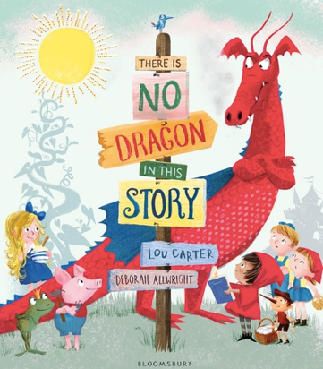  There is no Dragon in this story by Lou Carter and Deborah Allwright. Fiction (Links to traditional tales)  Skills: *Predict what might happen on the basis of what has been.  *Identify and explain key aspects of fiction and non-fiction text, such as characters, events, titles and information.  *Identify and explain the sequence of events in texts.  *Draw upon knowledge of vocabulary to understand the text.  *Ask and answer questions  (GD Compare stories with traditional tales).  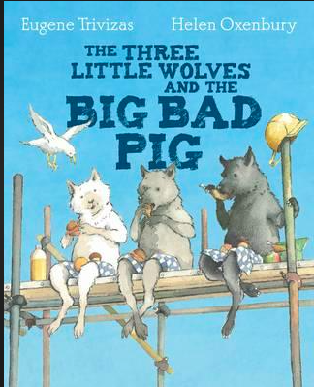  The Three Little Wolves and the Big Bad Pig by Eugene Trivizas and Helen Oxenbury. (4 Weeks) Fiction GD- challenge them to compare it to the traditional tale of the Three Little Pigs.  Skills:  *Predict what might happen on the basis of what has been.  * Identify and explain key aspects of fiction and non-fiction text, such as characters, events, titles and information.  *Identify and explain the sequence of events in texts.  *Draw upon knowledge of vocabulary to understand the text.  Dragon Poems by John Foster and Korky Paul. Poetry  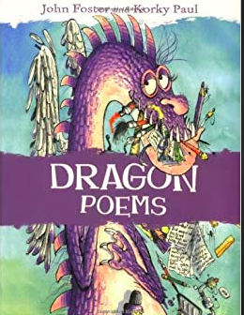  Skills: Retrieval and Vocabulary  *Draw upon knowledge of vocabulary to understand the text.  * Identify and explain key aspects of fiction and non-fiction text, such as characters, events, titles and information.  INFORM  Castles by Osbourne Heritage Non-Fiction (Great for topic link)  Skills: Retrieval and Vocabulary  *Draw upon knowledge of vocabulary to understand the text.  * Identify and explain key aspects of fiction and non-fiction text, such as characters, events, titles and information.  ENTERTAIN  The Bog Baby by Jeanne Willis Fiction (Links to loving something and letting it go). LS  Skills:  *Sequence the story and write captions.  *Draw on knowledge of vocabulary to understand texts.  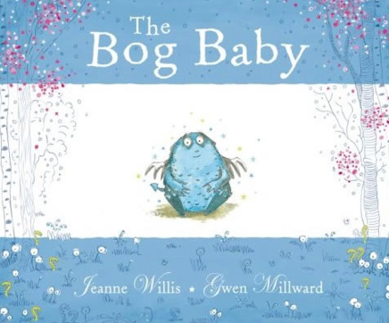  *Identify and explain key aspects of fiction and non-fiction text, such as characters, events, titles and information.  * Identify and explain the sequence of events in texts.  * Predict what might happen on the basis of what has been.  Story:  Og | ENTERTAIN  VLAD and The Great Fire of London by Kate Cunningham (2 weeks) TH Fiction  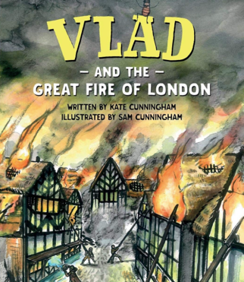  Skills:  *Draw on knowledge of  vocabulary  to understand texts.  *Identify and explain key  aspects of fiction and non-fiction  text, such as characters, events, titles and information.  *Make inferences from the text.  *To retrieve and infer information from a text.  *To predict what will happen using knowledge gained so far.  The Great Fire of London Poem by Paul Perro Poetry TES  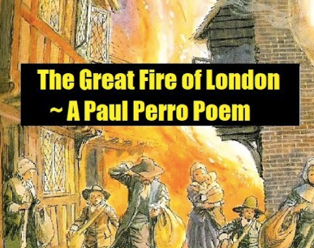  Skills:  *Identify and explain key aspects of fiction and non-fiction text, such as characters, events, titles and information.  *Identify and explain the sequence of events in texts.  *Draw upon knowledge of vocabulary to understand the text.  https://www.tes.com/teaching-resource/great-fire-of-london-poetry-reading-12083255  INFORM  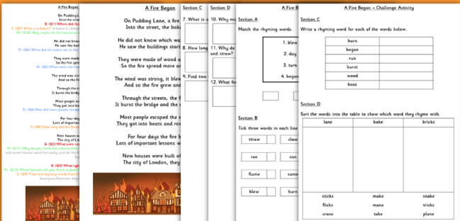  A Fire Began Poetry CS  Skills:  * Identify and explain key aspects of fiction and non-fiction text, such as characters, events, titles and information.  *Identify and explain the sequence of events in texts.  *Draw upon knowledge of vocabulary to understand the text.  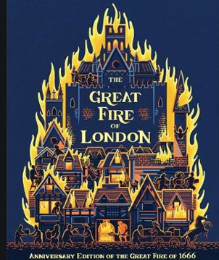  *Ask and Answer questions  INFORM  The Great Fire of London by Emma Adams Non-Fiction (Teaching Sparks)  Skills:  *Draw upon knowledge of vocabulary to understand the text.  * Identify and explain key aspects of fiction and non-fiction text, such as characters, events, titles and information.  *Ask and answer questions.  *Identify and explain the sequence of events in texts.  Flotsam by David Wiesner (links to Geography) Narrative Picture book no words.  Skills:  *Draw upon knowledge of vocabulary to understand the text.  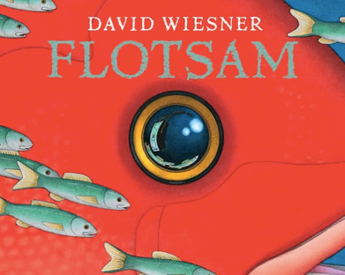  * Identify and explain key aspects of fiction and non-fiction text, such as characters, events, titles and information.  *Ask and answer questions.  *Identify and explain the sequence of events in texts.  * Predict what might happen on the basis of what has been.  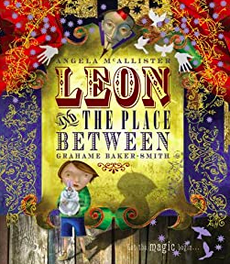  Leon and the Place in between by Graheme Baker Smith Fiction  Skills:  *Draw upon knowledge of vocabulary to understand the text.  * Identify and explain key aspects of fiction and non-fiction text, such as characters, events, titles and information.
Reading for Pleasure-Class Books
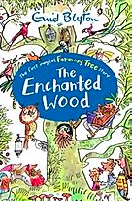  Enid Blyton  The Enchanted Wood  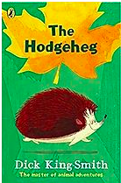  The Hedgehog by Dick King Smith  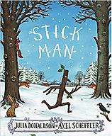  Stick Man by Julia Donaldson  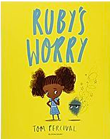  Ruby’s Worry by Tom Percival | 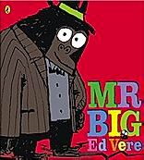  Mr Big by Ed Vere  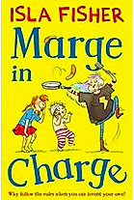  Marge in Charge by Isla Fisher  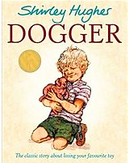  Dogger by Shirley Hughes |  | 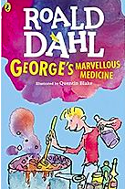  George’s Marvellous Medicine by Roald Dahl  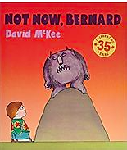  Not Now, Bernard by David McKee  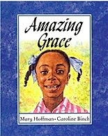  Amazing Grace by Mary Hoffman  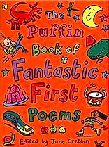  Fantastic First Poems By June Crebbin

Cycle 2
Title of Book/Reading Domain or skill | 1a Vocabulary | 1b Retrieval | 1c Sequencing | 1d Inference | 1e Prediction | Visualise | Clarify | Question
Autumn
Little Red Riding Hood
The Three Little Pigs
The Last Wolf
Good Little Wolf
Remembrance Day (Film)
The Tunnel
Bonfire Night Poems
Lily and The Snowman (Film)
Spring
There is no Dragon in this story
The Three Little Wolves and the Big Bad Pig
Dragon Poems
Castles
The Bog Baby
Summer
VLAD and The Great Fire of London
The Great Fire of London Poem
A Fire Began
The Great Fire of London
Flotsam
Leon and the Place in between

